Development of Scripts in Sysgem Enterprise Manager (SEM)

Contents

1. Preface 3
2. Overview: SEM Components 4
3. SEM Authorization Server 5
4. AuthServer Folder Structure 6
5. SEM ‘Layers’ of Routines 8
6. SEM Options Cache 9
7. SEM Options Cache Routines 10
8. Database Access in SAcM 11
9. Database Access: Example. 12
10. Example Database Access. (SAcM Audit record) 13
11. Example Database Access - (SAcM Audit record continued) 14
12. Viewing the detailed results of scripts 15
13. Starting to Edit a Display Script 16
14. Select a Display 17
15. Use the Navigation Bar to Navigate between Pages 18
16. “Columns” Page 19
17. Navigate to the “Scripts” Page 21
18. Main Display Scripts 22
19. Main Agent Scripts 23
20. Exercise 1 24
21. Main Post-processing Script 25
22. Exercise 2 26
23. Main Pre-processing Script 27
24. Exercise 3 28
25. Customer Include Files 29
26. Editing Customer Include Files 30
27. Editing Customer Include Files - continued 31
28. Variables Defined Automatically in SEM Scripts 32
29. Exercise 4 33
30. Menu Options 34
31. Passing Variables to Agent Scripts 36
32. Exercise 5 37
33. Subscriber 38
34. Current Subscriber 39
35. Exercise 6 40
36. Read before Edit (e.g. during a “Modify” menu option) 41
37. Suppress a Refresh & Modify a Display Entry in Situ 43
38. Exercise 7 44

Appendix A – Variables Defined Automatically in SEM Scripts 45
Appendix B - List of SAcM Include Files 50
Appendix C - List of Subroutines within each SAcM Include File 51
Appendix D - Alphabetical List of SAcM Include File Subroutines 62
Appendix E - List of compiled Sysgem:: library routines frequently used by SAcM 67

Preface
The purpose of this document is to provide course notes for training in the use of the Development Interface in Sysgem Enterprise Manager (SEM). They will be handed out as part of the course so that further notes may be taken. The content of this document is also available as a PowerPoint presentation which may be used later for self-paced training.

The structure and content of the document is based on the slides and an interactive demonstration of SEM that will be presented as part of the training course.

A further PowerPoint presentation is available giving the details of the practical exercises that also form part of the training course.

For any further information visit our website www.sysgem.com or contact support@sysgem.com.

Overview: SEM Components

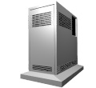
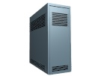

Management
Console
Managed Agents on Target Systems
Authorization Server

Slide 1.0

There are three basic components that are installed with Sysgem Enterprise Manager:

- Management Console: This is installed on the SEM user’s Windows workstation and provides the user interface (GUI) to the user.
- Agents: The SEM agents are installed on the target servers that are to be managed. They run as non-interactive processes on the different platform types, they communicate with the Management Consoles and run scripts on demand from the management Consoles, passing back the results to the Management Console for display to the SEM user.
- Authorization Server: The SEM Authorization Server is at the centre of the SEM architecture. To use SEM, a user has to start the SEM Management Console on their workstation and log into the SEM Authorization Server using a SEM username and password. Each SEM user account has a profile that defines a set of SEM permissions that have been granted to the user. On successfully logging into SEM the appropriate set of SEM display windows and scripts that the user has permission to use are downloaded from the Authorisation Server into the Management Console, and from there will interact with the user and the agents that the user is permitted to connect to.

Version 2.3 of SEM introduces an optional fourth component: the “SEM Proxy Server” which is a software server that sits between the Management Console and a designated set of SEM Agents. Communication messages between the Management Console and the Agents are directed through the SEM Proxy Server. The Proxy Server will perform some basic tasks such as checking whether the SEM user is authorised to connect to that particular set of agent, encrypting the communication messages through SSH Tunnels, auditing message interactions, etc. A SEM Proxy Server may be connected in series to other SEM Proxy Servers.

SEM Authorization Server

- SEM User Profiles (for SEM permissions) are held at the SEM AuthServer.
- SEM Scripts are held at the AuthServer and loaded into the GUI when a SEM user logs in.
- Libraries at the AuthServer are updated as scripts are developed.

Slide 2.0

The SEM Authorization Server (Windows Service) is used for the following purposes:

- It is location where SEM user accounts are stored.
- It validates SEM user login (username and password).
- It stores ‘Profile’ definitions that grant SEM permissions to the user’s logged-in session.
- It stores SEM libraries containing module scripts / windows / displays / entry forms / etc.
- It conducts ODBC access to central (SEM) databases on behalf of the SEM Management Consoles running on SEM user workstations.
- It provides access to a central repository folder known as the “SEM Options Cache”.

AuthServer Folder Structure
SAcM Audit Database
Contains:
Home Directories for Users and Script Libraries
SAcM Application Databases
Cache of Contents of Drop Down Lists
Perl Libraries used by SEM
SEM Agent & Working Directory
SAcM Subscriber Database
SEM GUI

Slide 3.0

- SAcM Audit Database: The default database type for “Out-of-the-box” SEM is Microsoft Access. This folder is the default location of the SAcMAudit.mdb file. All transactions conducted by SAcM on target servers are recorded in the SAcM Audit DB giving all details (except passwords) of the transaction, the identity of the target server and username, and the identity of the SEM user that initiated the transaction. The database can be redefined as (e.g. SQL Server) by redefining the ODBC settings on the Authorization Server.
- SEM Authorization Server:
  - Home directories for SEM users are stored in the “Sysgem\SEM Authorization Server\” folder.
  - “SEM Libraries” containing the scripts and UI for SEM Modules such as the Sysgem Account Manager Module (SAcM) are also stored under this folder.
  - The SEM Authorization Server executable program is stored in this folder.
- SEM Application Databases: A number of miscellaneous SEM databases are stored here including:
  - SAcMWAR.mdb
  - SAcMShareMgt.mdb
  - SAP_Simulation.mdb
- Options Cache: A number of files used to cache lists of values used (e.g. as drop down lists in SAcM input forms) are stored in this folder. For performance reasons, these files are also copied to the workstation of the SEM users, and any changes to the central set of files held on the Authorization Server machine are also copied to the workstation as they are accessed. Checksums of files content are used to ensure that local workstation copies are kept up to date.
- SEM Perl: This folder holds a private copy of the PERL executable and associated set of dll files etc. All Perl scripts run by SEM use this private copy of Perl. This copy of Perl exists to avoid any conflict between the version of Perl required by SEM and any version of Perl already installed on the server.
- SEM Server: This folder is used by the SEM Agent. It is the location of the Agent executable program. A sub-folder whose name includes the name of the agent, plus the string “Scripts Etc” is used as the temporary working directory for the Perl scripts executed by the agent. Any files left in this folder will be deleted the next time the Agent is restarted (normally with a reboot of the machine). Any sub-folders to the “Script etc” folder and the files within them will never be automatically deleted by the SEM Agent.
- SEM Subscribers: This is the location of the SAcM Subscriber DB. An “Identity Management” database of people together with pointers to the accounts owned by the individual subscriber records. The Subscriber DB is by default a Microsoft Access database, but this may be changed to be another database type such as Microsoft SQL Server by changing the system DSN settings in the ODBC Datasource Administrator.
- SEM User Interface: This folder is used by the “SEM Client.exe“ program that provides a GUI to the SEM user. There are various sub-folders to this folder including the “Modules” sub-folder that holds the libraries of SEM Modules shipped with the Sysgem installed kit.

SEM ‘Layers’ of Routines
‘Include File’ sub-routines, included at run-time.
Compiled routines available to scripts.
Perl Scripts.

Slide 4.0

SEM ‘Layers’ of Routines

- SEM Scripts are executed either by the ‘SEM Management Console’ (GUI) on the workstation or by ‘Agents’ on target servers.

- There are a set of standard (Sysgem) scripts that are invoked from menu options.

- Scripts that run on the workstation or on Windows servers are written in Perl. Scripts that run on VMS Agents are written in DCL. On UNIX servers they are written in Korn shell, & on eSeries Servers they are written in CL.

- “Include file” routines are incorporated into SEM scripts at run-time, immediately before a script is executed. To include an include file in a SEM script, add the line “#include <filename>” at the point in the script where it is required.

- Windows Perl scripts can invoke compiled routines from the Sysgem Perl Library by adding the line “use Sysgem;” and then invoking the routine with: “Sysgem::<routine name>. Scripts on other platforms can invoke executable programs made available by Sysgem on the target server.

SEM Options Cache

The local (workstation) cache is synchronized with the central cache

Management
Console
Authorization Server
OptionsCache
OptionsCache
Local cache
Central cache
cached files
Checksum
file
cached files
Checksum
file

Slide 5.0

A number of files used to cache lists of values (e.g. as drop down lists in SAcM input forms) are stored in the ‘Options Cache’ folder held centrally on the Authorization Server.

For performance reasons, these files are also copied to the workstations of the SEM users, and any changes to the central set of files held on the Authorization Server machine are also copied to the workstations when they are accessed.

Checksums of files content are used to ensure that local workstation copies are kept up to date.

If any of these centrally held Options Cache files are changed manually, then the central checksum file must also be rebuilt manually so that changes are reflected in the local workstation copies when they are accessed by the SEM GUI. To rebuild the central checksum file use the menu option:

SAcM
-> Enterprise Accounts
-> Options
-> Cache Maintenance.

SEM Options Cache Routines

- Options_SaveToFile()
Options_SaveToFile(“ORACLE”, “Permissions", \@permissionList);
- Options_LoadFromFile()
@PermissionList = Options_LoadFromFile (“ORACLE”, “Permissions ");

- Options_FileExists()
if (!Options_FileExists(“ORACLE", “Permissions"))

Slide 5.1

There are a number of routines available to access options cache text files from workstation and Agent scripts by including the “SAcM_Options_Cache” include file in that script … e.g.

#include SAcM_Tokens
#include SAcM_Options_Cache

Options_SaveToFile(“ORACLE”, “Permissions", \@permissionList);

The routines shown on this slide are frequently used in SAcM scripts. Others are available in the include file.

The convention for an Options Cache text file name is: String1_String2.txt … where “String1” and “String2” are the first two parameters sent to the Options_SaveToFile() and Options_LoadFromFile() routines.

Options_SaveToFile() is given the address of an array (as the third parameter) that contains the lines of information that will be written to the file. Each element of the array is written on one line in the output file.

Options_LoadFromFile() returns an array where element of the array is one line from the input file.

Notice that that both SacM_Options_Cache and SAcM_Tokens include files are required if you need to use the Options cache routines, because some of the routines within SAcM_Options_Cache require some of the routine in SAcM_Tokens.

We will describe how to view and edit include files and workstation scripts later in the course.

Database Access in SAcM

Management
Console
ODBC
SAcM Databases
Agent
Authorization Server

Slide 6.0

Database Access in SAcM

- All DB access by standard SAcM scripts is conducted through ODBC

- SEM Authorization Server provides a central resource service to access ODBC

- “Compiled routines” (e.g. Sysgem::ODBCAddRecord) in a sysgem library instigate such access
- “Include file” routines (written in Perl) provide a layer on top of the compiled sysgem library
- Examples of databases accessed by SAcM scripts are:
  - SAcM Audit Trail
  - SAcM Subscribers DB
  - Web Access Request (WAR) DB
  - SAcM Share management DB
  - SAP Simulation DB

Database Access: Example.
SEM Routines to read / write via ODBC

- Compiled SEM routines held in Sysgem Perl Library
e.g. Sysgem::ODBCAddRecord()

- Perl Subroutine, e.g.: “UMLogAddAccount()”
calls: Sysgem::ODBCAddRecord()
- UMLogAddAccount()” is held in the SAcM Include file:
“SAcM_Logfile”
- SEM Include Files are held in a SEM Module Library

Slide 6.1

Example Database Access. (SAcM Audit record)

Code within a standard SAcM Script:
use Sysgem;
#include SAcM_Logfile
my $AudSeq = AuditSeqNumber();

UMLogAddAccount($SysgemComputer,
$SysgemUsername,
$ENTRY_UN,
"Exchange2000 mailbox modified",
$SERVER_TYPE,
$SERVER_NAME,
"Audit Seq. No..: $AudSeq",
@mods);

Slide 6.2

ODBC Example – writing an Audit Record to the SAcM Audit DB

- UMLogAddAccount() is a Perl sub-routine held in the Include File “SAcM_Logfile” which is contained in the SAcM module library.
- The first six parameters to the routine are fields stored in the separate data fields of the table “Table_Actions_Ex”:
  - The identity of the SEM users’s workstation
  - The identity of the SEM user
  - The identity of the target user account
  - The nature of the transaction
  - The platform type/application type of target server/application
  - The name of the target Agent

- The rest of the parameters are stored in the data field of the Audit record, starting with the Audit Sequence number (a unique reference number applied to this transaction).
- In the above example, the remainder of the data fields are each stored in the elements of the array “@mods”.

Example Database Access - (SAcM Audit record continued)

Call to the (compiled) Sysgem library routine from within ‘included’ routine: UMLogAddAccount()

use Sysgem;

$status = Sysgem::ODBCAddRecord($db_umlog_dsn,
"",
$db_umlog_table_actions,
\@fields,
\@values,
$error);

Slide 6.3

ODBC Example – writing an Audit Record to the SAcM Audit DB

- ODBCAddRecord() is a compiled routine held in the sysgem library:
\Sysgem\SEM Perl\site\lib\auto\Sysgem\sysgem.dll
which in turn calls routines in
Sysgem\SEM Perl\bin\Sysgem_ODBC.dll
The ODBC request is then piped through to the Authorization Server process, which then calls the ODBC primitives to satisfy the request.

Viewing the detailed results of scripts

As part of the training exercises you will need to be able to view the detailed output of SEM scripts that have run on the workstation and on target servers.

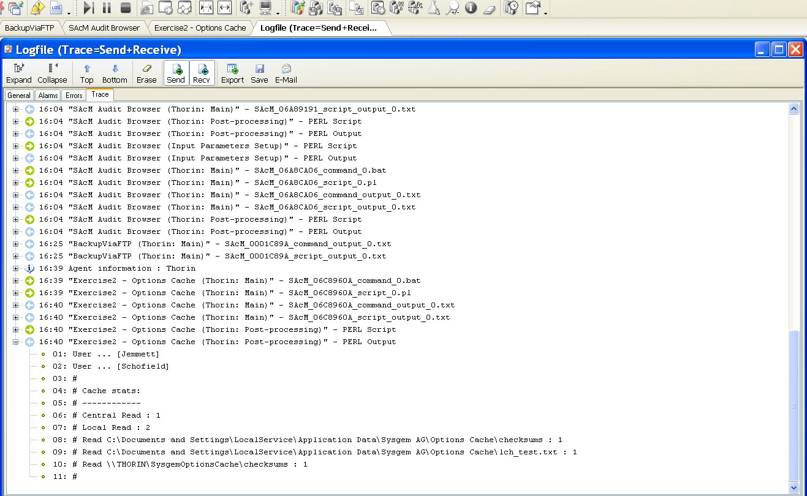
Set verbose on for debugging (Send, Rcv)

Slide7.0

Script Logfile Window

To see the details of the input and output of all the scripts running in a SEM transaction, view the SEM Logfile in “Verbose Mode”

  - Open the Logfile window by pressing the “LOG” icon at the top of SEM window (or use main menu option “Window” -> “Logfile” / Alt-G)
  - Expand the logfile tree using the “+” / “-” symbols in the tree.

Starting to Edit a Display Script

From this point forward the interactive training will use a logged in SEM session and in a live demo will enter the SEM development interface to explain the features in an existing set of display scripts.

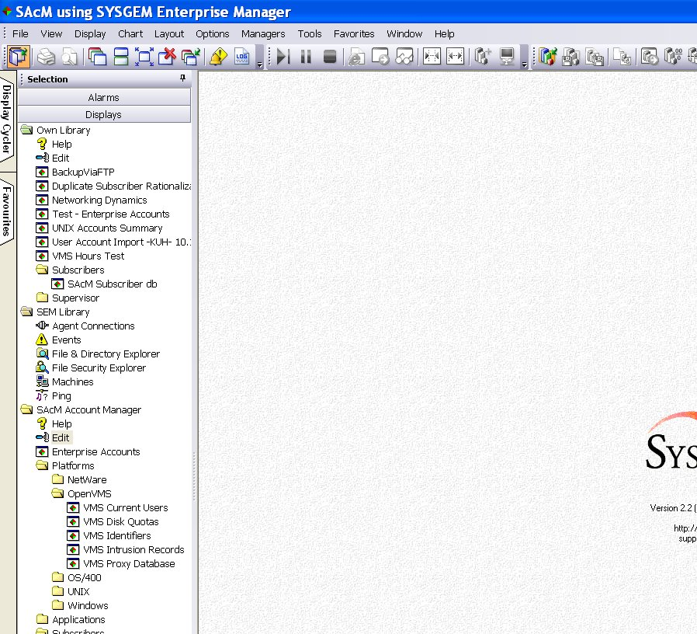
With the correct permissions, the “Edit” option appears

With the correct SEM permissions applied, the “Edit” options appear

Slide 8.0

SEM Development - Starting to Edit a Display Script

The ability to enter the SEM development environment is controlled by:

a). having the appropriate customer license;
b). having the appropriate profile setting in the SEM user account.

A SEM account with a profile setting of “Define Custom Displays” enabled will see and be able to invoke the “Edit” option under his own and any mapped SEM modules.

Double click the mouse pointer on the edit option to start the SEM Development Interface on the appropriate library. Use the SAcM Account Manager library.

Select a Display

Select “Enterprise Accounts”

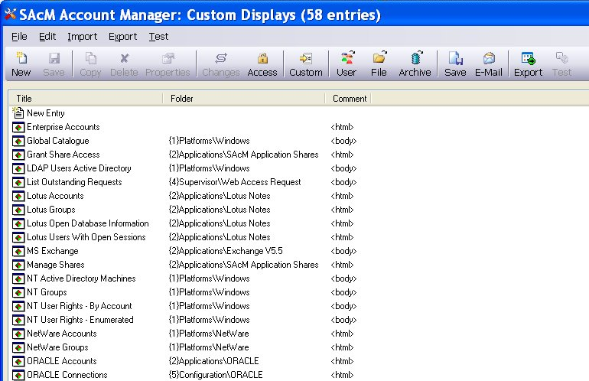
Double click a display to start the SEM editor

Slide 8.1

Select a Display for editing.

All the Custom Displays in the library are listed, the example shown in the slide is the Sysgem User Account Management Module (SAcM). Double click on “Enterprise Accounts”.

Use the Navigation Bar to Navigate between Pages

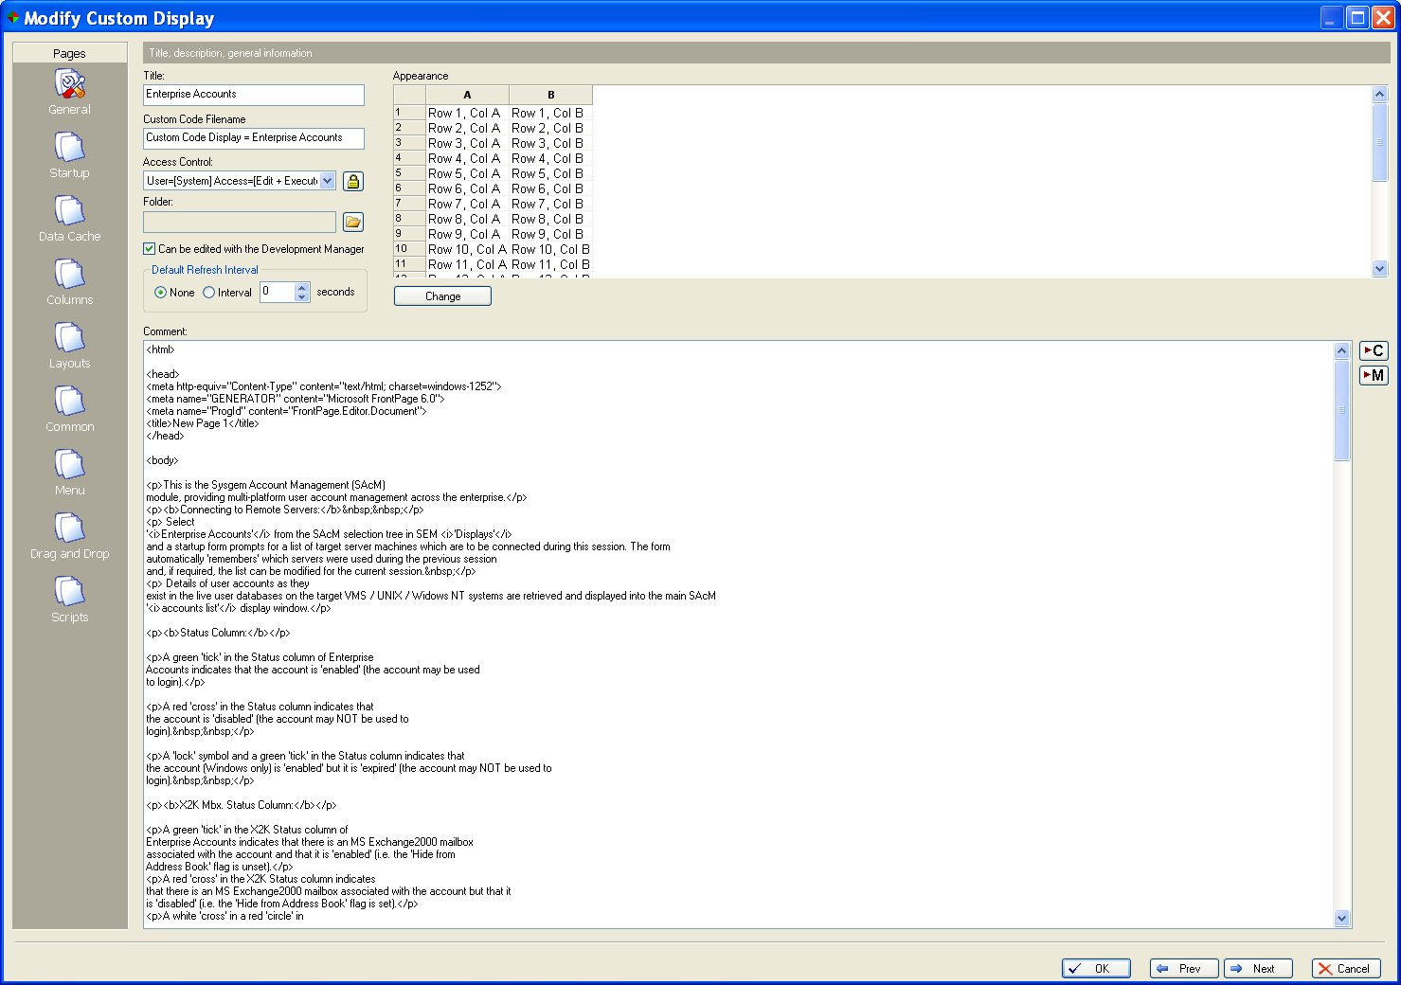
Navigation Bar... Select the “Columns” page

Slide 8.2

Use the Navigation Bar to Navigate between Pages

For quick navigation between the pages in the editor, use the navigation bar on the left of the screen.

In a custom display definition there are nine pages (which will be described during the course of this training):

    - General
    - Startup
    - Data Cache
    - Columns
    - Layouts
    - Common
    - Menu
    - Drag and Drop
    - Scripts

We will start by looking at the “Columns” page. Click “Columns” in the navigation bar.

“Columns” Page

The Columns page defines the characteristics of the text shown on a SEM Display Window

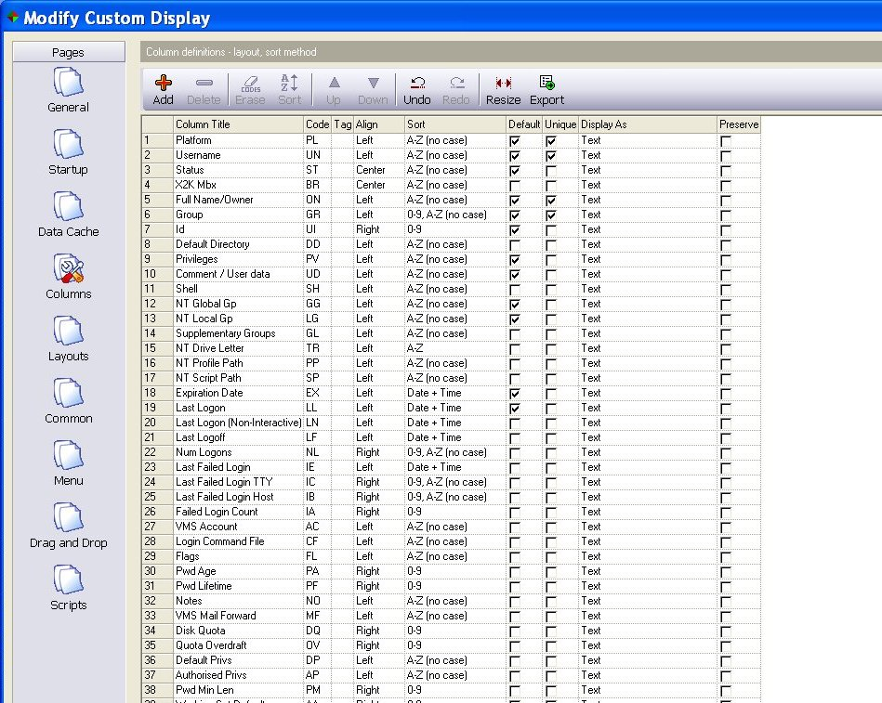
Note, particularly, the Column Title and Column Code

Slide 8.3

“Columns” Page

The Columns page defines the characteristics of the text shown on a SEM Display Window. Each column in the display is defined by an entry on this SEM Editor page.

An new entry can be added by pressing the “+” Add option or an existing entry deleted by selecting the entry (or entries) and pressing the “-” Delete option.

The following fields define the characteristics of the displayed columns in a Custom Display Window:

    - “Title” gives the text of the column header;
    - “Code” gives a two alpha character field that is used by scripts to reference this column;
    - “Tag” gives a script a more meaningful reference name to a column;
    - “Align” defines how displayed text should be aligned within the column (Left, Right, Centre);
    - “Sort” gives alternative sort algorithms for when the user clicks on the column title;
    - “Default” defines whether the column is displayed or not when the display window is first presented. Other sets of columns can be selected / deselected by the user at his own preference;
    - “Unique” should be selected when the content of the column is unique on the display, or the combination of fields make the record unique in the display window. It is used by the SEM framework to uniquely identify selected rows of information;
    - “Display As” indicates whether the content of the cell should be displayed as text or (e.g.) as a histogram for numerical data, etc.;
    - “Preserve” – select the “Preserve” checkbox if this column has been added as a customization, and needs to be added to a new library if the standard Sysgem library is upgraded to a new version.

Before we move to the next editor page take note that the “Username” column has a code of “UN” and the “Platform” column has a code of “PL”

Navigate to the “Scripts” Page

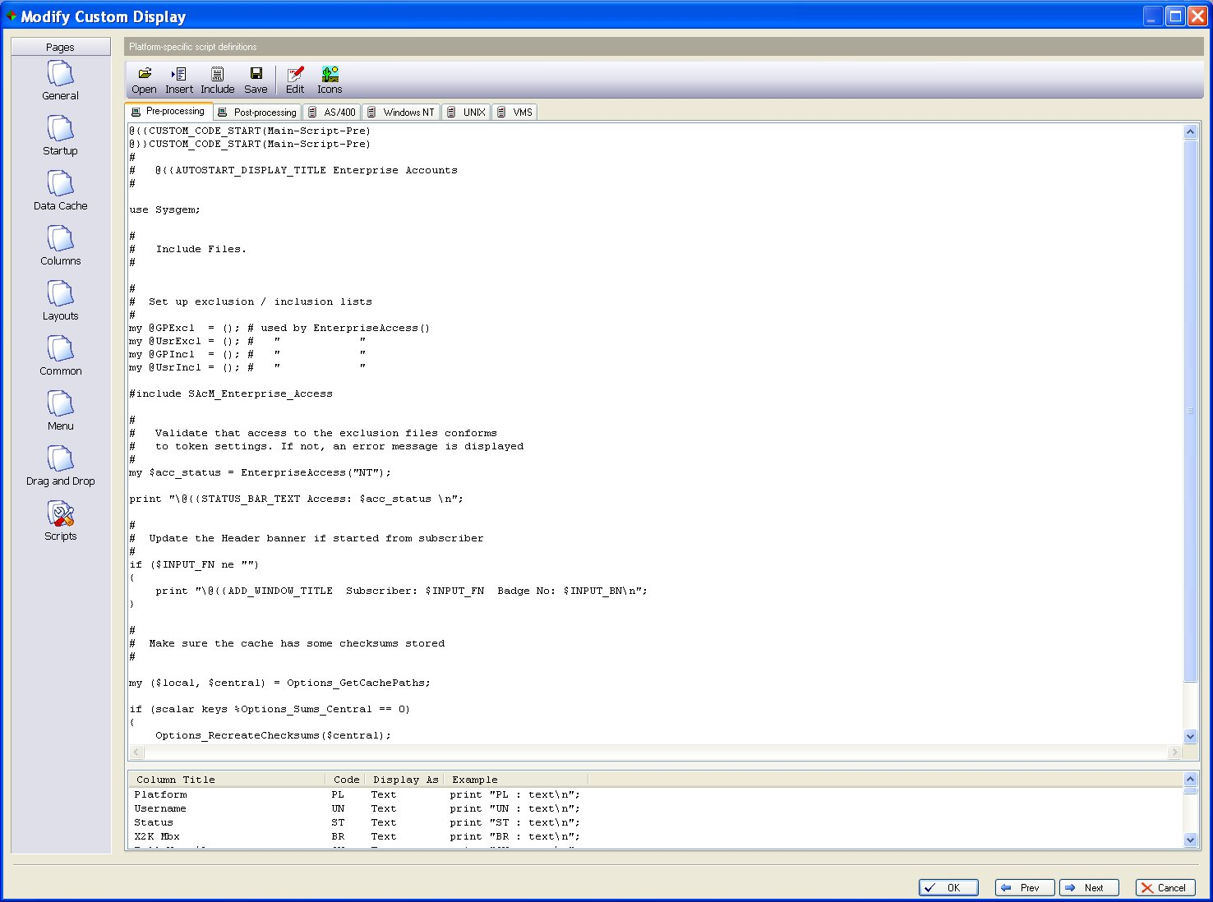
Select “Scripts”

Slide 8.4

Navigate to the Scripts Page

The next editor page that we will look at is the “Scripts” page…

Main Display Scripts

Pre- & Post- Processing

Target
(platform-specific)
Scripts

Slide 8.5

Main Display Scripts

These scripts run after the Display Window is started and before the display is loaded with data. The output from the scripts is used to populate the display with data.

Pre- & Post- Processing Scripts: These run on the SEM user’s workstation before and after the agent scripts are run on the target servers. They are written in the Perl scripting language.

Target Server Scripts: These are written in the command language of the target operating system, except for Windows which is in Perl.

Main Agent Scripts

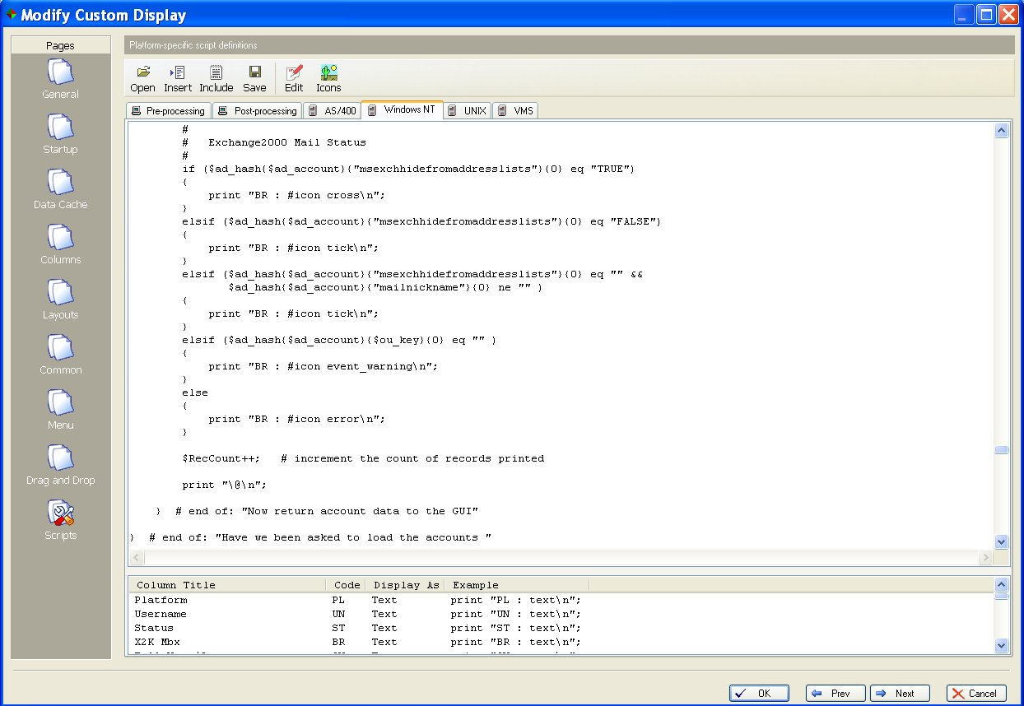

Slide 8.6:

Main Agent Scripts on Target Servers

Output from the target servers can be sent directly into the display window by printing to standard output from the target script … e.g. (from Perl)

print “PL : Windows\n”: # platform
print “UN : schofiem\n”; # username
print “\@\n”; # next displayed row / record

Exercise 1

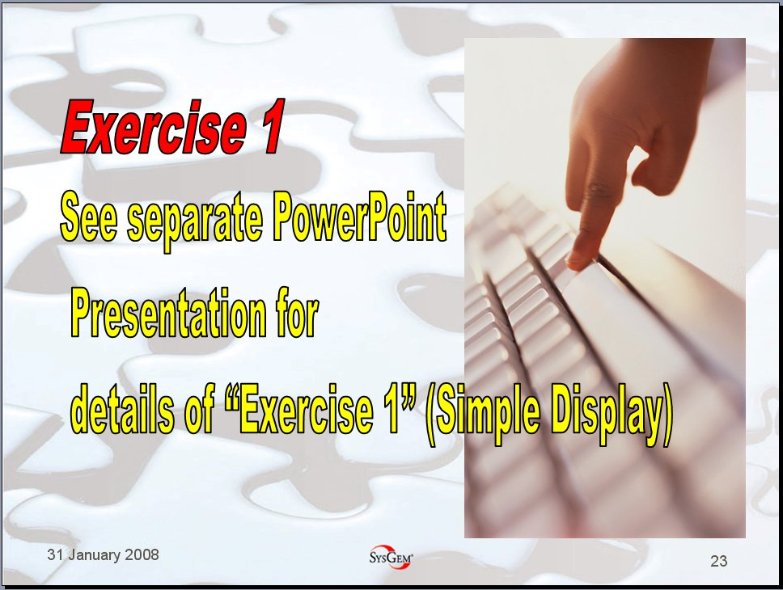
Exercise 1

A simple display to run a agent script on the appropriate platform and display a small amount of information in the display window.

Main Post-processing Script

It is possible to intercept (& filter/modify) the output from Agent scripts before they are presented in the display window.

#
# Replace the output.
#
print "{{REPLACE_VALUES=YES\n“;

#
# Load Agent output into input array.
#
LoadInputArray(); # Agent output now in @input_array

foreach $input (@input_array)
{
…

Slide 8.7

Post Processing - Intercept (& filter) Agent Output

Output from the Agent can be intercepted by the Post-Processing routine with:

print "{{REPLACE_VALUES=YES\n“;

This suppresses the output from being displayed in the display window.

The Agent output can be placed in an array by calling the following routine:

LoadInputArray();

The array “@input_array” can then be parsed, e.g.

foreach $input (@input_array)
{
if ($input =~ m/UN : /)
{
# … etc.
}
else
{
#
# print the item to the display window
#
print $input . “\n”;
}
}

Exercise 2

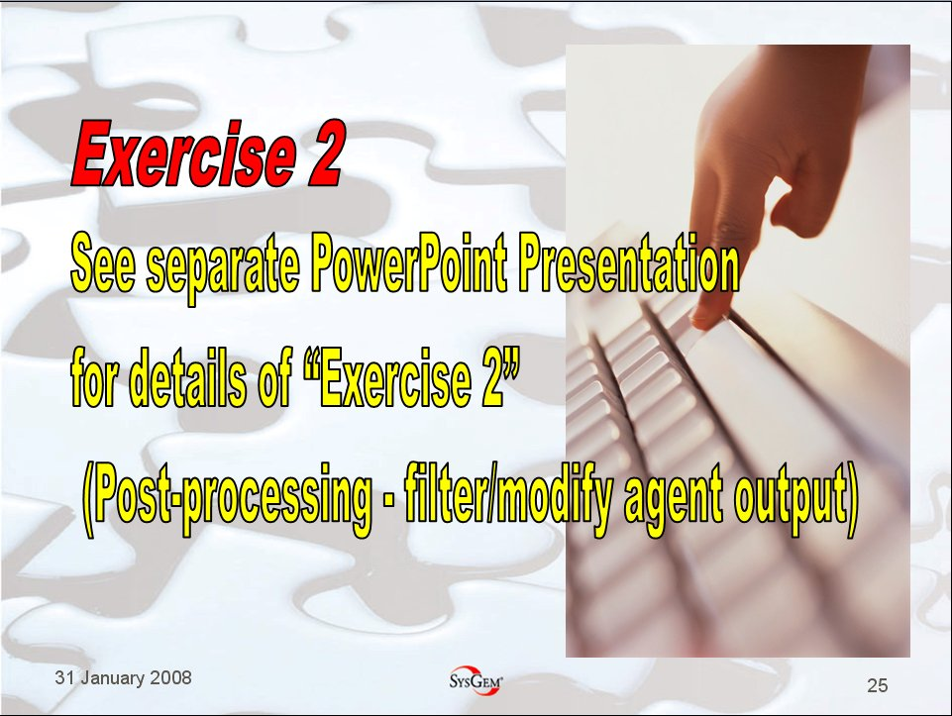

Exercise 2

A modification of the Exercise 1 display to intercept and filter the displayed output in the post-processing script before it is presented in the display window.

Main Pre-processing Script

The main pre-processing script is actioned first in the sequence: 1. Pre-processing; 2. Agent Scripts; 3. Post-processing; but its explanation has been left to last because it has very little involvement in the data processing of display data. The script is used to define the content of status bars, title bars, and it is used to allow the window to be started from other windows using the option: “@{{AUTOSTART_DISPLAY_TITLE”

#
# @{{AUTOSTART_DISPLAY_TITLE <Display name here>
#

# Status Bar
#
print "\@{{STATUS_BAR_TEXT <status text here>\ \n";
#
# Header Banner
#
print "\@{{ADD_WINDOW_TITLE <banner text here>\n";

Slide 8.8

If this window is to be started from a menu option on another window, then the other window will identify this window using the auto-start name defined by the string:

# @{{AUTOSTART_DISPLAY_TITLE <display name>

Status bar and header banner messages may also be displayed as shown in the slide above.

*IMPORTANT*

Take care with output from the main Pre-Processing script because this piped automatically into each of the multi-platform agent scripts and included in the script for execution as script commands.

Exercise 3



Exercise 3

A modification of the Exercise 2 display to text strings in the header banner and status bar of the display window.

Customer Include Files

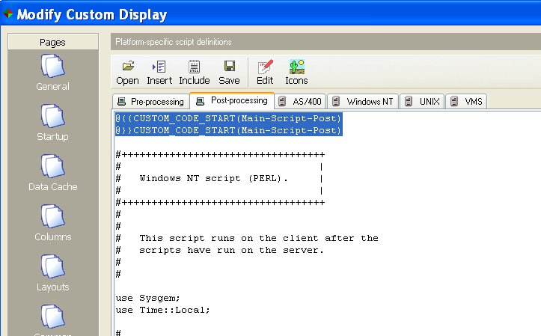
Most Enterprise Accounts scripts have two lines at the top and bottom similar to these.

Slide 8.9

Customer Include Files

- SAcM Enterprise Accounts scripts are provided with the ability to include custom code that is inserted at run time from customer include files.
- Customer include files are preserved when SEM or a module is upgraded to a later version.
- The two highlighted lines in the slide are replaced at run time with lines of code that have been edited into a customer include file between an identical pair of lines in the customer include file.
- We will now look at a customer include file. From the main scripts page of the Modify Custom Display window, click on the “Include” icon at the top of the “’Modify Custom Display’ window.

Editing Customer Include Files

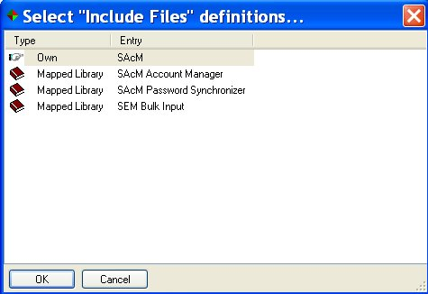
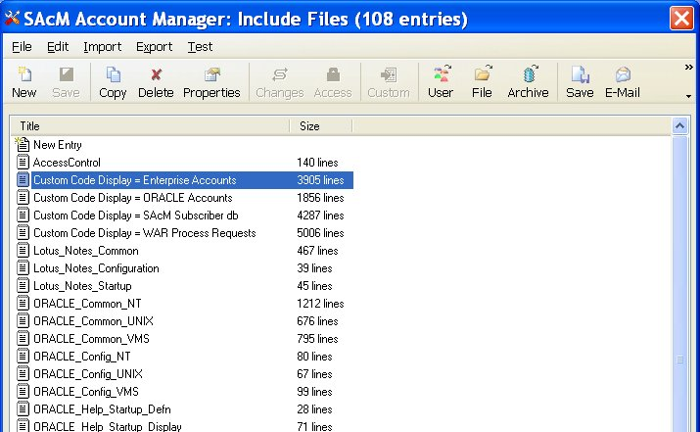

Slide 8.10

Editing Customer Include Files

- Select the mapped library “SAcM Account Manager”.
- Any include file starting with “Custom Code Display =” is marked in such a way that when a new version of SEM is being installed or a new version of a SEM Module is being imported, these include file will not be overwritten, so that customisations you make will not be lost.
- “Custom Code Display =Enterprise Accounts” and “Custom Code Display =ORACLE Accounts” are two examples of custom include files that will be preserved between updates. They, respectively, apply custom additions to the standard scripts held in the two Displays: “Enterprise Accounts” and “ORACLE Accounts”.
- Double Click on the Include File: “Custom Code Display = Enterprise Accounts”.

Editing Customer Include Files - continued

Locate “Main-Script-Post”:
#++
#
# Main Script Post
#
# Added .....: 14-Jul-2000 06:35:39
# Platform ..: Windows
#
#--

@{{CUSTOM_CODE_START(Main-Script-Post)
@}}CUSTOM_CODE_START(Main-Script-Post)

@{{CUSTOM_CODE_FINISH(Main-Script-Post)
@}}CUSTOM_CODE_FINISH(Main-Script-Post)

Slide 8.11

- “CUSTOM_CODE_START” is the prefix for the two lines at the head of the script and “CUSTOM_CODE_FINISH” is the prefix for the two lines at the bottom of the script.

Insert custom script:
#++
#
# Main Script Post
#
# Added .....: 14-Jul-2000 06:35:39
# Platform ..: Windows
#
#--

@{{CUSTOM_CODE_START(Main-Script-Post)

print “Hello World \n”;

@}}CUSTOM_CODE_START(Main-Script-Post)

Slide 8.12

- Insert the custom script and save the edited file.

Variables Defined Automatically in SEM Scripts

- Before a script is run, SEM places variables into the script that describe the environment in which the script runs.

- Appendix A describes these variables.

Slide 8.13

Exercise 4

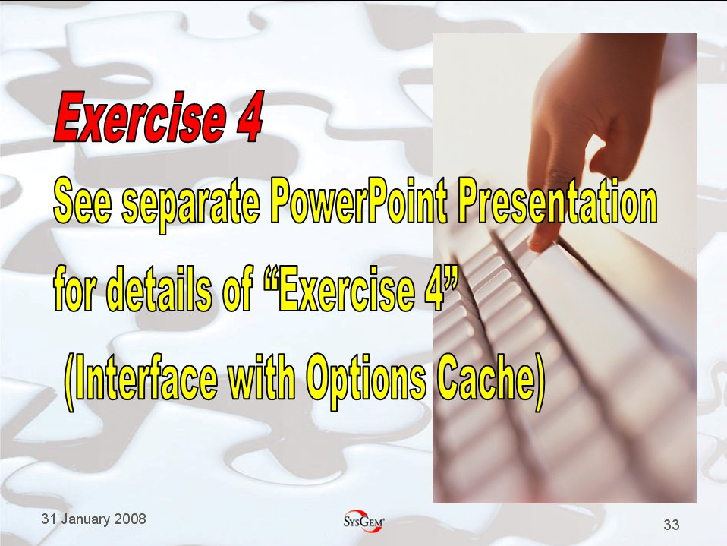

Exercise 4

A modification of the Exercise 3 display to practice reading from and writing to the SAcM Options Cache.

Menu Options

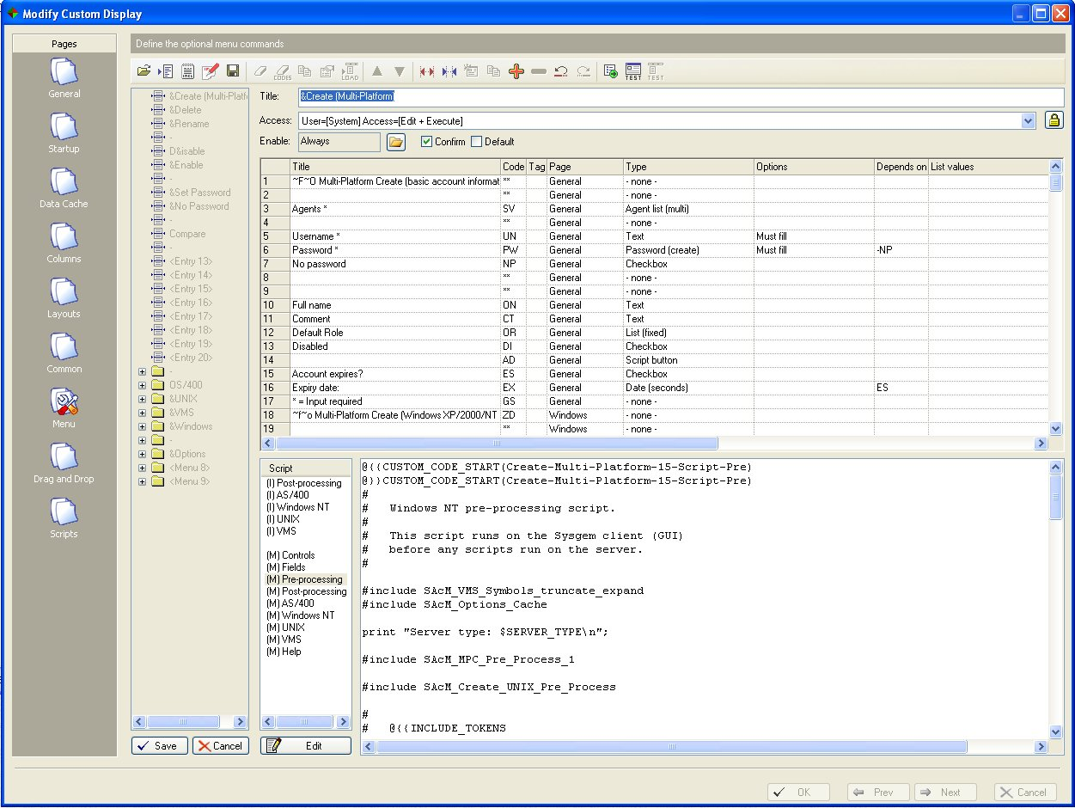
5.
4.
3.
2.
1.

Editing Menu Options

  - Navigate to the “Menu” page
  - Double click on “Enterprise Accounts”
  - Press the “Test” icon to view the input form
  - Double click on a field to see field definition
  - Double Click on required script to edit it.

Purpose of the Scripts:
(I) – Initial Scripts are run before the input form is displayed – e.g. if you are about to modify a user account, you need to read the account on the target system to extract the fields before the modify form is displayed.
“(M) Controls” is used to add or remove additional (custom fields) to an input form.
“(M) Fields” script is run to insert initial contents into the input form when it is first displayed.
“(M) Pre-processing” is run immediately after the user has pressed “Apply” on the input form and before the transaction is transferred to the agent. It is used e.g. to validate the input on the workstation before the data is sent to the agent.
“(M) Post-processing” is run immediately after the transaction has been processed on the agent, and before the results are displayed on the screen.
“(M) AS/400“; “(M) Windows NT”; “(M) UNIX”; “(M) VMS are the agent scripts that run on the target servers. The scripts are transferred with the input data each time the menu option is invoked. Custom code is included at run time (See
slide 8.9 – Customer Include Files) for a fuller explanation.
“(M) Help“ is used to define the help text that is displayed with this menu option.

Passing Variables to Agent Scripts

#
# Insert a line into the agent script from a “Menu Pre-Process” script
#
print "\@{{ADD_SVR <string to insert> \n";

#
# For example…
#
if ($SERVER_TYPE =~ m/UNIX/)
{
print "\@{{ADD_SVR echo \"$CC\" \n";
}
elsif ($SERVER_TYPE =~ m/VMS/)
{
print "\@{{ADD_SVR \$ write sys$output \"$CC\" \n";
}
elsif ($SERVER_TYPE =~ m/Windows/)
{
print "\@{{ADD_SVR print \"$SubCC\\n\";\n";
}

Passing Variables to Agent Scripts

The pre-processing script in a menu option can pass command lines into the agent script before the agent script is transferred to the target server.

The command lines are inserted as part of the first lines of the agent script.

So, in the example above, if the variable $CC in the pre-processing script contains the string “Cost Centre: HFH”

Then in a Unix agent script the following line would be added:

echo “Cost Centre: HFH”

In a VMS agent script:

$ write sys$output “Cost Centre: HFH”

and in a Windows agent script:

print “Cost Centre: HFH\n”;

Exercise 5



Exercise 5

A modification of the Exercise 4 display to practice using database access mechanisms & writing to the SAcM Audit log.

Subscriber

Current Subscriber

Exercise 6



Exercise 6

A modification of the Exercise 5 display to practice working in the context of a current SAcM Subscriber record.

Read before Edit (e.g. during a “Modify” menu option)

An “Account Modify” transaction may have a form similar to the following simple example:

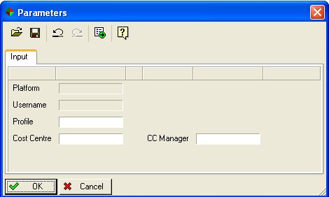

Before the input can be acted upon, the fields of data need to be filled in from the current state of the user account.

In a menu option, the following initialization (I) scripts run on the target agent before the input form is displayed. This feature is used, for example, to read the current details of a user account prior to those details being displayed in the input form of a “Modify” transaction.

(I) Windows NT
(I) Unix
(I) VMS

Out put from these scripts is placed in the array:

@script_output

… and made available to the “(M) Fields” script. The purpose of the “(M) Fields” script is to populate the fields in the form with data, so it can parse the data read by the “(I) Initialise” scripts and place the individual fields in the input form using Perl statements such as:

print “XX : <field extracted from @script_output> \n”;

It would also be possible to structure the lines of data obtained by the initialization scripts (I) so that it is already in the format required by the script (M) Fields with the preceding field code separated by space-colon-space from the field data. The (M) Fields script would then simply print each line in the @script_output array:

foreach my &line (@script_output)
{
print $line . “\n”;
}

Suppress a Refresh & Modify a Display Entry in Situ

After a menu option has run on a target server, the Display is automatically refreshed (so that any changes made on the target server are now reflected in the display window).

However, if the display is such that it takes a long time to refresh the window, then this can be suppressed within the (M) Post-Processing script by inserting the comment line:

# @{{REFRESH_DISPLAY=NO

#
# Do not refresh the display.
#
# @{{REFRESH_DISPLAY=NO

#
# Modify this entry on the display.
#
print "\@{{DSP_MOD 99 $ENTRY_99\n"; # Index of entry to modify

print "\@{{DSP_MOD XX new value\n";

Also, if required, the content of a selected display record can be updated with:
print "\@{{DSP_MOD 99 $ENTRY_99\n"; # Index of entry to modify
print "\@{{DSP_MOD XX new value\n"; #(where XX is the field code)

Each appropriate field may be changed on the selected display record.

In the (M) Post-processing script: Output from the main agent script may be accessed with:

foreach $line (@script_output)
{

}

Exercise 7


Exercise 7

A modification of the Exercise 6 display to write Modify Menu option and display the results in Display window.
.

Appendix A – Variables Defined Automatically in SEM Scripts

This appendix shows a list of the commonly used variables automatically defined in scripts by the SEM framework before a script is executed. This information can also be seen by expanding the log fie entries in ‘verbose mode’.

A). Main Display Scripts

A1). Main Display Script – Pre-Processing

$INPUT_XX Contents of Start-up Fields (field code XX)

$AUTH_SVR_ADDRESS DNS Name / IP Address of Authorization Server
$AUTH_SVR_PORT IP Port number of Authorization Server Service
$DISPLAY_TITLE Name of Display
$USER_NT_USERNAME Windows username of current logged in SEM user
$USER_NT_COMPUTER Workstation DNS Name / IP Address of current logged in SEM user
$USER_SYSGEM_USERNAME SEM username of current logged in SEM user
$EXECUTABLE_DIR Working directory for this script

A2). Main Display Script – Post-Processing

$INPUT_XX Contents of Start-up Fields (field code XX)

$AUTH_SVR_ADDRESS DNS Name / IP Address of Authorization Server
$AUTH_SVR_PORT IP Port number of Authorization Server Service
$DISPLAY_TITLE Name of Display
$USER_NT_USERNAME Windows username of current logged in SEM user
$USER_NT_COMPUTER Workstation DNS Name / IP Address of current logged in SEM user
$USER_SYSGEM_USERNAME SEM username of current logged in SEM user
$EXECUTABLE_DIR Working directory for this script

$server_name SEM Agent name of the agent that has just responded
$server_type OS Platform type of responding Agent
$server_sub_type e.g. “Server” / "Workstation";

@CurrentServers Array - list of Agents selected for connection
@ConnectedAgents Array – list of Agents that have been successfully connected
%UserTokens e.g. $UserTokens{"SAcM Full"}{"Menu Create"} = 1;
%UserProfile e.g. $UserProfile{"Access"}{"Override Access Control"} = 0;

A3). Main Display Script – Windows Agent

$INPUT_XX Contents of Start-up Fields (field code XX)

$USE_AUTH_SVR_PROXY 0 / 1 = whether the Authorization Server is to be used to
Resolve ODBC / Options cache access
$AUTH_SVR_ADDRESS DNS Name / IP Address of Authorization Server
$AUTH_SVR_PORT IP Port number of Authorization Server Service

$SERVER_NAME Agent name of this target server

$CLIENT_ADDRESS IP Address of workstation
$CLIENT_COMPUTER DNS Name of workstation
$CLIENT_DATE_TIME System time of workstation

$CLIENT_USERNAME SEM username of current logged in SEM user

A4). Main Display Script – UNIX Agent

INPUT_XX Contents of Start-up Fields (field code XX)

SERVER_NAME Agent name of this target server

CLIENT_ADDRESS IP Address of workstation
CLIENT_COMPUTER DNS Name of workstation
CLIENT_DATE_TIME System time of workstation

CLIENT_USERNAME SEM username of current logged in SEM user

A5). Main Display Script – VMS Agent

$ INPUT_XX Contents of Start-up Fields (field code XX)

$ SERVER_NAME Agent name of this target server

$ CLIENT_ADDRESS IP Address of workstation
$ CLIENT_COMPUTER DNS Name of workstation
$ CLIENT_DATE_TIME System time of workstation

$ CLIENT_USERNAME SEM username of current logged in SEM user

B). Menu Scripts

B1). Menu Option – Pre-Process

$STARTUP_XX Input fields (XX = variable code) in the start-up window

$INPUT_XX Contents of the input form Fields (XX = variable code)

$SELECTED_ENTRIES Number of selected entries in the display

$ENTRY_XX Each field in the selected display entry (XX = variable code)

$before_after{AA}{"before"} The state of each field of the input form as it was first presented
$before_after{AA}{"after"} The state of each field of the input form when “Apply” pressed

#
# - if in context of a selected subscriber record:
#
$Classes{"SAcM Subscriber"}{"XX"}{"title"} Field name as shown on Subscriber input/modify
$Classes{"SAcM Subscriber"}{"XX"}{"value"} Content of field (XX=variable code) of selected rec.

#
# Workstation / Agent info
#
$Auth_Svr_Address DNS Name / IP Address of Authorization Server
$Auth_Svr_Port IP Port number of Authorization Server Service
$SysgemComputer Workstation DNS Name / IP Address of current logged in SEM user
$SysgemDisplayName Name of Display
$SysgemMenuOption Name of the selected menu option
$SysgemUsername SEM username of current logged in SEM user

$AGENT_NAME Target agent that the script is about to be sent to
$AGENT_TYPE Target agent platform type
$AGENT_SUB_TYPE e.g. “Server” / "Workstation"

$USE_AUTH_SVR_PROXY 0/1 whether to use Auth Server for resolving ODBC requests

B2). Menu Option – Post-Process

as for B1 Menu Option – Pre-Process except:

- $before_after is not defined, and
- $SELECTED_ENTRIES is not defined.

B3). Menu Option – Main Script – Windows Agent

$STARTUP_XX Input fields (XX = variable code) in the start-up window

$INPUT_XX Contents of input fields (XX = variable code)

$ENTRY_XX Content of each field in the selected display entry (XX = variable code)

$USER_NT_USERNAME Windows username of current logged in SEM user
$USER_NT_COMPUTER Workstation DNS Name / IP Address of current logged in SEM user
$USER_SYSGEM_USERNAME SEM username of current logged in SEM user

$ CLIENT_ADDRESS IP Address of workstation
$ CLIENT_AUTH_SVR DNS Name / IP Address of Authorization Server
$ CLIENT_DATE_TIME Date time in format (e.g. "4-FEB-2008 12:07:54")
$ CLIENT_USER_DIR Working directory for this script

$AGENT_DEF_NAME Target agent that the script is about to be sent to

B4). Menu Option – Main Script – UNIX Agent

$ STARTUP_XX Input fields (XX = variable code) in the start-up window

$ INPUT_XX Contents of input fields (XX = variable code)

$ ENTRY_XX Content of each field in the selected display entry (XX = variable code)

$ USER_NT_USERNAME Windows username of current logged in SEM user
$ USER_NT_COMPUTER Workstation DNS Name / IP Address of current logged in SEM user
$ USER_SYSGEM_USERNAME SEM username of current logged in SEM user

$ CLIENT_ADDRESS IP Address of workstation
$ CLIENT_AUTH_SVR DNS Name / IP Address of Authorization Server
$ CLIENT_DATE_TIME Workstation date / time in format: (e.g. "4-FEB-2008 12:07:54")

$ AGENT_DEF_NAME Target agent that the script is running on

B5). Menu Option – Main Script – VMS Agent

STARTUP_XX Input fields (XX = variable code) in the start-up window

INPUT_XX Contents of input fields (XX = variable code)

ENTRY_XX Content of each field in the selected display entry (XX = variable code)

USER_NT_USERNAME Windows username of current logged in SEM user
USER_NT_COMPUTER Workstation DNS Name / IP Address of current logged in SEM user
USER_SYSGEM_USERNAME SEM username of current logged in SEM user

CLIENT_ADDRESS IP Address of workstation
CLIENT_AUTH_SVR DNS Name / IP Address of Authorization Server
CLIENT_DATE_TIME Workstation date / time in format: (e.g. "4-FEB-2008 12:07:54")

AGENT_DEF_NAME Target agent that the script is running on

Appendix B - List of SAcM Include Files
1 AccessControl
2 Lotus_Notes_Common
3 ORACLE_Common_NT
4 ORACLE_Common_VMS
5 ORACLE_Config_NT
6 ORACLE_Config_VMS
7 ORACLE_PreProcessing
8 ORACLE_Routines_NT
9 ORACLE_Routines_VMS
10 ORACLE_Startup
11 OpenVMS_Queues
12 PowerShell_Interface
13 Reports
14 SAcM_AS400_Fields
15 SAcM_AS400_Parse_Fields
16 SAcM_AccessControl
17 SAcM_Common_Date_Routines
18 SAcM_Config_Agent_Def
19 SAcM_Config_Data
20 SAcM_Config_Workstation_Def
21 SAcM_Connex
22 SAcM_Create_UNIX_Account
23 SAcM_Custom_Parameter_Subroutines
24 SAcM_Delete_NT_Account
25 SAcM_Delete_UNIX_Account
26 SAcM_Delete_VMS_Account
27 SAcM_Disable_VMS_Account
28 SAcM_EA_Common_UNIX
29 SAcM_Enable_VMS_Account
30 SAcM_Enterprise_Access
31 SAcM_Exchange_2000
32 SAcM_Exchange_CheckVersion
33 SAcM_GenericVMS_Subroutines
34 SAcM_GetVMS_UIC_Group
35 SAcM_Global_Catalog
36 SAcM_HP-UX_read_secure_passwd
37 SAcM_HideFromAddressBook
38 SAcM_Logfile
39 SAcM_Lotus_Refresh
40 SAcM_MPC_Create_Exchange_Mailbox

41 SAcM_MPC_Create_NT_Account
42 SAcM_MPC_Create_NetWare_Account
43 SAcM_MPC_Create_SAP_Account
44 SAcM_MPC_Create_VMS_Account
45 SAcM_MPC_Field_Script_2
46 SAcM_MS_Exchange_fields
47 SAcM_Modify_NT_Account
48 SAcM_Modify_UNIX_Account
49 SAcM_NIS
50 SAcM_NT_Account_Status
51 SAcM_Novell_Common
52 SAcM_Options_Cache
53 SAcM_RBAC_Bulk_Import_Pre
54 SAcM_Reconcile_Remove_All_Suggestions
55 SAcM_Reconcile_Repair_All_Suggestions
56 SAcM_RefreshUnixDisplay
57 SAcM_SAP_Modify_Account
58 SAcM_SAP_Options
59 SAcM_SAP_Routines
60 SAcM_SAP_Simulation
61 SAcM_Set_Org_Unit
62 SAcM_ShareMgmt_Common
63 SAcM_ShareMgmt_Fields
64 SAcM_ShowVMS_DiskQuotas
65 SAcM_Sub_Sync
66 SAcM_Subscriber
67 SAcM_Tokens
68 SAcM_VMS_Audit_Trail
69 SAcM_VMS_GetHwType
70 SAcM_VMS_Symbols_truncate_expand
71 SAcM_Validate_SQL_DB_Access
72 SAcM_WAR_DB
73 SAcM_WarGetParams
74 SAcM_WarInProgress
75 SAcM_WarSubmitted
76 SAcM_WarUpdateResults
77 Security_Database
78 VMS_Proxies

Appendix C - List of Subroutines within each SAcM Include File

1 AccessControl
AccessControlAllowAccount
AccessControlEnabled
AccessControlInitialize
AccessControlStatus

2 Lotus_Notes_Common
AddToCache
InitialiseAndConnect
OptionsLoadFromFileEx
PrepareNotesFiles
RegDelPwdValue
RegSetPwdValue
SaveCache

3 ORACLE_Common_NT
ExecSQLPlus
GetDefaultSvrMgrExe
GetOracleDataCache1
GetOracleDataCache2
GetOracleDataCacheInstances
GetOracleDisplayDataEx
GetOracleDisplayDataExAnalyze
GetOracleDisplayDataExPost
GetOracleDisplayDataExPre
GetOracleDisplayDataExPreAll
OptionsLoadFromFiles
OracleAuditLog
RunMenuCommand
RunMenuCommandEx

4 ORACLE_Common_VMS
GetOracleDataCache1:
GetOracleDisplayDataExPre:
GetOracleDisplayDataExPreAll:
OracleInitialise:
OracleInitialiseForInstance:
RunMenuCommand:
RunMenuCommandEx:

5 ORACLE_Config_NT
ValidConfigEntries

6 ORACLE_Config_VMS
ValidConfigEntries:

7 ORACLE_PreProcessing
OracleCommonPreProcessing
OracleCommonPreProcessingEx
OracleCommonPreProcessingEx2

8 ORACLE_Routines_NT
ORACLE_DeleteUser
ORACLE_DisableUser
ORACLE_EnableUser

9 ORACLE_Routines_VMS
ORACLE_DeleteUser:
ORACLE_DisableUser:
ORACLE_EnableUser:

10 ORACLE_Startup
OracleRestoreAgents
OracleRestoreLogonInfo
OracleRestoreLogonPassword
OracleSaveAgents
OracleSaveLogonInfo
OracleSaveLogonPassword
OracleStartupPrompt
OracleStartupScript
OracleStartupScriptPwd

11 OpenVMS_Queues
job_status_to_text:
queue_flags_to_text:
queue_status_to_text:
queue_type_to_text:

12 PowerShell_Interface
RunPowerShellCommand

13 Reports
AllEntryInfo
Banner
CompareLists
Diagnostics
DisplayTable
EntryInfo
GetDataIntoHash1
GetDataIntoHash2
GetFieldArrayUnique
GetFieldScalar
PageSummary
RecordCount
ReportTitle

14 SAcM_AS400_Fields
DirectoryError
GetProfileField
LoadAS400Fields
TranslateError

15 SAcM_AS400_Parse_Fields
ParseOS400Fields

16 SAcM_AccessControl
AccessToPrivs
CanModGroup
CanModPriv
OverrideAC

17 SAcM_Common_Date_Routines
DateMMM2NN
DateNN2MMM
DateTimeToEpoch
DateTo8Char
DateToEpoch
GMTtoLocal

18 SAcM_Config_Agent_Def
Define_SAcM_Agent_Configs

19 SAcM_Config_Data
GetDSNDatabaseName
GetDSNProductName
GetInstallationKey
GetSharePath

20 SAcM_Config_Workstation_Def
Define_SAcM_WorkstationConfigs

21 SAcM_Connex
ConnexAdd
ConnexAddNotes
ConnexAddSAP
ConnexAllHosts
ConnexAllNotesHosts
ConnexAllSAPHosts
ConnexCheckExists
ConnexCheckExistsNotes
ConnexCheckExistsSAP
ConnexCurrentDBMS
ConnexDefineDatabase
ConnexDeleteEntry
ConnexFixSQLWhere
ConnexGetAll
ConnexGetEntry
ConnexGetNotesEntry
ConnexGetSAPData
ConnexGetSAPEntry
ConnexModify
ConnexModifyNotes
ConnexModifySAP
ConnexPassword
ConstructConnexFileName

22 SAcM_Create_UNIX_Account
CreateFullAccount

23 SAcM_Custom_Parameter_Subroutines
Construct_Custom_Variables
Construct_HomeDir_Hash
Construct_MBX_Hash
CustomParametersToAgent

24 SAcM_Delete_NT_Account
SafeToDelete

25 SAcM_Delete_UNIX_Account
DeleteAccount

26 SAcM_Delete_VMS_Account
DeleteVMSAccount:
RemoveDirTree:
RemoveDiskQuota:

27 SAcM_Disable_VMS_Account
DisableVMSAccount:

28 SAcM_EA_Common_UNIX
AuditLog
DisplayFile
EnableDisableAccount
ExpireAccountPassword
GetAccountEntry
ManualDisableAccount
ManualEnableAccount
MatchPattern
ReadAuditLog
RequireExecutableFile
SetAccountPassword
SetPassword
ShowAccountInformation
ValidatePlatform

29 SAcM_Enable_VMS_Account
EnableVMSAccount:

30 SAcM_Enterprise_Access
EnterpriseAccess
ExpandVMSWildcardList
FatalError
RemoveBlanks

31 SAcM_Exchange_2000
Exch2007DeleteMailbox
Exch2KAccountOption
Exch2KAccountOptionOnServer
Exch2KFindServerFromMDB

32 SAcM_Exchange_CheckVersion
Exchange_CheckVersion

33 SAcM_GenericVMS_Subroutines
Concat_INPUT_UN:
Concat_STARTUP_UN:
dcl_command:
remove_file:
show_file:
type_file:

34 SAcM_GetVMS_UIC_Group
GetUIC_Group:

35 SAcM_Global_Catalog
SearchGlobalCatalog
TraceTime

36 SAcM_HP-UX_read_secure_passwd
ReadSecureHPpasswd

37 SAcM_HideFromAddressBook
SAcM_HideFromAddressBook

38 SAcM_Logfile
AuditSeqNumber
AuditTransactNumber
Audit_ConstructPathName
ConstructAuditFileName
DisplayAuditSeq
IncrementAuditTransactNumber
UMLogAdd
UMLogAddAccount
UMLogAddAccountModify
UMLogAddGroup
UMLogAddIdentifier
UMLogAddIntrusion
UMLogAddModification
UMLogBuildField
UMLogCurrentDBMS
UMLogDefineDatabase
UMLogEnabled
UMLogFixSQLWhere

39 SAcM_Lotus_Refresh
PrField
RefreshLotus

40 SAcM_MPC_Create_Exchange_Mailbox
IncludeSpecifiedMailAddr
MPC_CheckExchangeUnique
MPC_Create_Exchange_Mailbox
ReformatName

41 SAcM_MPC_Create_NT_Account
DN_exists
DeduceUPN
GetDistinguishedName
GetLDAPEntries
MPC_Create_NT_Account
ReformatName
SetFlag
UPNExists
UpdateFld
UpdateTS

42 SAcM_MPC_Create_NetWare_Account
MPC_Create_NetWare_Account

43 SAcM_MPC_Create_SAP_Account
AddFieldValue
AddOptFieldValue
MPC_Create_SAP_Account

44 SAcM_MPC_Create_VMS_Account
add_pmdf_entry:
copy_all_rights:
create_account:
set_pathworks:

45 SAcM_MPC_Field_Script_2
DisableField
LoadListIntoField

46 SAcM_MS_Exchange_fields
GetExchangeServer
IsValidAttribute

47 SAcM_Modify_NT_Account
AuditChange
DN_exists
GetDistinguishedName
GetLDAPEntries
Modify_NT_AD
Modify_NT_Account
Modify_NT_SAM
SetFlag
UpdateFld
UpdateTS

48 SAcM_Modify_UNIX_Account
AuditChange
ModifyAccount

49 SAcM_NIS
NIS_AddSuppGroup
NIS_ChangeGroupID
NIS_CheckTempUser
NIS_CopyToLocal
NIS_DelSuppGroup
NIS_DeleteGroup
NIS_DisableUser
NIS_Init
NIS_MoveToNISMap
NIS_PushMaps
NIS_RenameGroup
NIS_RenameUser
NIS_SetPrimGroup
NIS_TranslateUsername

50 SAcM_NT_Account_Status
AccountMustExist
CheckAccountExists
CheckGlobalAccountExists
DisplayAccount
ShowAccountStatus

51 SAcM_Novell_Common
ClearField
NetwareInit
SetField

52 SAcM_Options_Cache
AddUAFMemToCache
AddUICsToCache
BuildFileListFromAuthSvr
FillGapsInUIC
LastPlusOneUIC
LoadOrgUnits
LoadServerNameCache
LoadUICsFromCache
MaxUICUID
MinUICUID
NextAvailableUIC
OptionsLoadFromFile
OptionsRemoveFile
OptionsSaveToFile
Options_AppendFileLines
Options_CheckAccess
Options_ConstructFilename
Options_CopyLocalCache
Options_CountOpen
Options_FileExists
Options_GenerateChecksumForData
Options_GenerateChecksumForfile
Options_GetCachePaths
Options_IsLocalPath
Options_LoadFromFile
Options_LoadFromGivenFile
Options_ReadChecksums
Options_ReadFileLines
Options_RecreateChecksums
Options_SaveToFile
Options_StatFile
Options_WriteChecksums
Options_WriteFileLines
ReadFileFromAuthSvr
SaveOrgUnits
SaveServerNameCache

53 SAcM_RBAC_Bulk_Import_Pre
FormatSpecialCharacters

54 SAcM_Reconcile_Remove_All_Suggestions
Remove_All_Suggestions

55 SAcM_Reconcile_Repair_All_Suggestions
Repair_All_Suggestions

56 SAcM_RefreshUnixDisplay
RefreshUnixDisplay
RemoveDuplicates

57 SAcM_SAP_Modify_Account
AddModFieldValue
AddModFieldValues

58 SAcM_SAP_Options
BuildLogonString
BuildLogonStringFromToken
RefreshSAPCachedLists

59 SAcM_SAP_Routines
SAP_Delete_User
SAP_DisableUser
SAP_EnableUser
SAP_ModifyOneField
SAP_SetPassword

60 SAcM_SAP_Simulation
SAPSimAddUser
SAPSimConstructDatabaseFilename
SAPSimDefineDatabase
SAPSimDeleteUser
SAPSimEnumerationList
SAPSimEnumerationLists
SAPSimFixSQLWhere
SAPSimModifyUser
SAPSimPrintAllRecords

61 SAcM_Set_Org_Unit
GetDistinguishedName
GetOUDistinguishedName
SetOrgUnit

62 SAcM_ShareMgmt_Common
AppListFilename
CompareDates
CreateTable
DefineDatabase
GetCurrentDBMS
GetTokenValues
MonthToNumber
OverrideAC
ShareFixSQLWhere
TokenAssigned
TokenValueAssigned

63 SAcM_ShareMgmt_Fields
SetDefaultPaths

64 SAcM_ShowVMS_DiskQuotas
show_quota:

65 SAcM_Sub_Sync
ShowSummary

66 SAcM_Subscriber
Subscriber_ConstructPathName

67 SAcM_Tokens
GetTokenValues
TokenAssigned
TokenValueAssigned

68 SAcM_VMS_Audit_Trail
AddAuditEvent:
AddAuditTrailFileAccess:
AddAuditTrailSysuaf:
DefineAccessRightsMask:

69 SAcM_VMS_GetHwType
AccountsExe:
AuditEventExe:
BlowfishExe:
GetHwType:

70 SAcM_VMS_Symbols_truncate_expand
AbbreviateVMSFlags
AbbreviateVMSPrivs
ExpandVMSFlags
ExpandVMSPrivs
SplitSymbol
TruncateSymbols

71 SAcM_Validate_SQL_DB_Access
ValidateAccessToSQL_DB

72 SAcM_WAR_DB
DefineWarDatabase
GetCurrentWarDBMS
WarDBCreateTable
WarFixSQLWhere

73 SAcM_WarGetParams
GetWarParams
UpdateTargetScript

74 SAcM_WarInProgress
WarInProgress

75 SAcM_WarSubmitted
WarSubmitted

76 SAcM_WarUpdateResults
AnyWarErrors
UpdateWarStatus
WarUpdateResults
WriteWarResults

77 Security_Database
SysSecAdd
SysSecAddData
SysSecAddDataFlag
SysSecCategoryShortForm
SysSecDefineDatabase
SysSecDeleteAllDataEntries
SysSecDeleteDataEntry
SysSecFixSQLWhere
SysSecGetNextDataIndex
SysSecList
SysSecPlatformShortForm
SysSecRemoveDataFlag
SysSecSetDataFlags
SysSecSetNextDataIndex
SysSecValidCategory
SysSecValidFlag
SysSecValidLevel
SysSecValidPlatform

78 VMS_Proxies
ProxyRemoteUsers:
UpdateProxies:

Appendix D - Alphabetical List of SAcM Include File Subroutines

AbbreviateVMSFlags Include File...: SAcM_VMS_Symbols_truncate_expand
AbbreviateVMSPrivs Include File...: SAcM_VMS_Symbols_truncate_expand
AccessControlAllowAccount Include File...: AccessControl
AccessControlEnabled Include File...: AccessControl
AccessControlInitialize Include File...: AccessControl
AccessControlStatus Include File...: AccessControl
AccessToPrivs Include File...: SAcM_AccessControl
AccountMustExist Include File...: SAcM_NT_Account_Status
AccountsExe: Include File...: SAcM_VMS_GetHwType
AddAuditEvent: Include File...: SAcM_VMS_Audit_Trail
AddAuditTrailFileAccess: Include File...: SAcM_VMS_Audit_Trail
AddAuditTrailSysuaf: Include File...: SAcM_VMS_Audit_Trail
AddFieldValue Include File...: SAcM_MPC_Create_SAP_Account
AddModFieldValue Include File...: SAcM_SAP_Modify_Account
AddModFieldValues Include File...: SAcM_SAP_Modify_Account
AddOptFieldValue Include File...: SAcM_MPC_Create_SAP_Account
AddToCache Include File...: Lotus_Notes_Common
AddUAFMemToCache Include File...: SAcM_Options_Cache
AddUICsToCache Include File...: SAcM_Options_Cache
AllEntryInfo Include File...: Reports
AnyWarErrors Include File...: SAcM_WarUpdateResults
AppListFilename Include File...: SAcM_ShareMgmt_Common
AuditChange Include File...: SAcM_Modify_UNIX_Account
AuditEventExe: Include File...: SAcM_VMS_GetHwType
AuditLog Include File...: SAcM_EA_Common_UNIX
AuditSeqNumber Include File...: SAcM_Logfile
AuditTransactNumber Include File...: SAcM_Logfile
Audit_ConstructPathName Include File...: SAcM_Logfile
Banner Include File...: Reports
BlowfishExe: Include File...: SAcM_VMS_GetHwType
BuildFileListFromAuthSvr Include File...: SAcM_Options_Cache
BuildLogonString Include File...: SAcM_SAP_Options
BuildLogonStringFromToken Include File...: SAcM_SAP_Options
CanModGroup Include File...: SAcM_AccessControl
CanModPriv Include File...: SAcM_AccessControl
CheckAccountExists Include File...: SAcM_NT_Account_Status
CheckGlobalAccountExists Include File...: SAcM_NT_Account_Status
ClearField Include File...: SAcM_Novell_Common
CompareDates Include File...: SAcM_ShareMgmt_Common
CompareLists Include File...: Reports
Concat_INPUT_UN: Include File...: SAcM_GenericVMS_Subroutines
Concat_STARTUP_UN: Include File...: SAcM_GenericVMS_Subroutines
ConnexAdd Include File...: SAcM_Connex
ConnexAddNotes Include File...: SAcM_Connex
ConnexAddSAP Include File...: SAcM_Connex
ConnexAllHosts Include File...: SAcM_Connex
ConnexAllNotesHosts Include File...: SAcM_Connex
ConnexAllSAPHosts Include File...: SAcM_Connex
ConnexCheckExists Include File...: SAcM_Connex
ConnexCheckExistsNotes Include File...: SAcM_Connex
ConnexCheckExistsSAP Include File...: SAcM_Connex
ConnexCurrentDBMS Include File...: SAcM_Connex
ConnexDefineDatabase Include File...: SAcM_Connex
ConnexDeleteEntry Include File...: SAcM_Connex
ConnexFixSQLWhere Include File...: SAcM_Connex
ConnexGetAll Include File...: SAcM_Connex
ConnexGetEntry Include File...: SAcM_Connex
ConnexGetNotesEntry Include File...: SAcM_Connex
ConnexGetSAPData Include File...: SAcM_Connex
ConnexGetSAPEntry Include File...: SAcM_Connex
ConnexModify Include File...: SAcM_Connex
ConnexModifyNotes Include File...: SAcM_Connex
ConnexModifySAP Include File...: SAcM_Connex
ConnexPassword Include File...: SAcM_Connex
ConstructAuditFileName Include File...: SAcM_Logfile
ConstructConnexFileName Include File...: SAcM_Connex
Construct_Custom_Variables Include File...: SAcM_Custom_Parameter_Subroutines
Construct_HomeDir_Hash Include File...: SAcM_Custom_Parameter_Subroutines
Construct_MBX_Hash Include File...: SAcM_Custom_Parameter_Subroutines
CreateFullAccount Include File...: SAcM_Create_UNIX_Account
CreateTable Include File...: SAcM_ShareMgmt_Common
CustomParametersToAgent Include File...: SAcM_Custom_Parameter_Subroutines
DN_exists Include File...: SAcM_Modify_NT_Account
DateMMM2NN Include File...: SAcM_Common_Date_Routines
DateNN2MMM Include File...: SAcM_Common_Date_Routines
DateTimeToEpoch Include File...: SAcM_Common_Date_Routines
DateTo8Char Include File...: SAcM_Common_Date_Routines
DateToEpoch Include File...: SAcM_Common_Date_Routines
DeduceUPN Include File...: SAcM_MPC_Create_NT_Account
DefineAccessRightsMask: Include File...: SAcM_VMS_Audit_Trail
DefineDatabase Include File...: SAcM_ShareMgmt_Common
DefineWarDatabase Include File...: SAcM_WAR_DB
Define_SAcM_Agent_Configs Include File...: SAcM_Config_Agent_Def
Define_SAcM_WorkstationConfigs Include File...: SAcM_Config_Workstation_Def
DeleteAccount Include File...: SAcM_Delete_UNIX_Account
DeleteVMSAccount: Include File...: SAcM_Delete_VMS_Account
Diagnostics Include File...: Reports
DirectoryError Include File...: SAcM_AS400_Fields
DisableField Include File...: SAcM_MPC_Field_Script_2
DisableVMSAccount: Include File...: SAcM_Disable_VMS_Account
DisplayAccount Include File...: SAcM_NT_Account_Status
DisplayAuditSeq Include File...: SAcM_Logfile
DisplayFile Include File...: SAcM_EA_Common_UNIX
DisplayTable Include File...: Reports
EnableDisableAccount Include File...: SAcM_EA_Common_UNIX
EnableVMSAccount: Include File...: SAcM_Enable_VMS_Account
EnterpriseAccess Include File...: SAcM_Enterprise_Access
EntryInfo Include File...: Reports
Exch2007DeleteMailbox Include File...: SAcM_Exchange_2000
Exch2KAccountOption Include File...: SAcM_Exchange_2000
Exch2KAccountOptionOnServer Include File...: SAcM_Exchange_2000
Exch2KFindServerFromMDB Include File...: SAcM_Exchange_2000
Exchange_CheckVersion Include File...: SAcM_Exchange_CheckVersion
ExecSQLPlus Include File...: ORACLE_Common_NT
ExpandVMSFlags Include File...: SAcM_VMS_Symbols_truncate_expand
ExpandVMSPrivs Include File...: SAcM_VMS_Symbols_truncate_expand
ExpandVMSWildcardList Include File...: SAcM_Enterprise_Access
ExpireAccountPassword Include File...: SAcM_EA_Common_UNIX
FatalError Include File...: SAcM_Enterprise_Access
FillGapsInUIC Include File...: SAcM_Options_Cache
FormatSpecialCharacters Include File...: SAcM_RBAC_Bulk_Import_Pre
GMTtoLocal Include File...: SAcM_Common_Date_Routines
GetAccountEntry Include File...: SAcM_EA_Common_UNIX
GetCurrentDBMS Include File...: SAcM_ShareMgmt_Common
GetCurrentWarDBMS Include File...: SAcM_WAR_DB
GetDSNDatabaseName Include File...: SAcM_Config_Data
GetDSNProductName Include File...: SAcM_Config_Data
GetDataIntoHash1 Include File...: Reports
GetDataIntoHash2 Include File...: Reports
GetDefaultSvrMgrExe Include File...: ORACLE_Common_NT
GetDistinguishedName Include File...: SAcM_Set_Org_Unit
GetExchangeServer Include File...: SAcM_MS_Exchange_fields
GetFieldArrayUnique Include File...: Reports
GetFieldScalar Include File...: Reports
GetHwType: Include File...: SAcM_VMS_GetHwType
GetInstallationKey Include File...: SAcM_Config_Data
GetLDAPEntries Include File...: SAcM_Modify_NT_Account
GetOUDistinguishedName Include File...: SAcM_Set_Org_Unit
GetOracleDataCache1 Include File...: ORACLE_Common_NT
GetOracleDataCache1: Include File...: ORACLE_Common_VMS
GetOracleDataCache2 Include File...: ORACLE_Common_NT
GetOracleDataCacheInstances Include File...: ORACLE_Common_NT
GetOracleDisplayDataEx Include File...: ORACLE_Common_NT
GetOracleDisplayDataExAnalyze Include File...: ORACLE_Common_NT
GetOracleDisplayDataExPost Include File...: ORACLE_Common_NT
GetOracleDisplayDataExPre Include File...: ORACLE_Common_NT
GetOracleDisplayDataExPre: Include File...: ORACLE_Common_VMS
GetOracleDisplayDataExPreAll Include File...: ORACLE_Common_NT
GetOracleDisplayDataExPreAll: Include File...: ORACLE_Common_VMS
GetProfileField Include File...: SAcM_AS400_Fields
GetSharePath Include File...: SAcM_Config_Data
GetTokenValues Include File...: SAcM_Tokens
GetUIC_Group: Include File...: SAcM_GetVMS_UIC_Group
GetWarParams Include File...: SAcM_WarGetParams
IncludeSpecifiedMailAddr Include File...: SAcM_MPC_Create_Exchange_Mailbox
IncrementAuditTransactNumber Include File...: SAcM_Logfile
InitialiseAndConnect Include File...: Lotus_Notes_Common
IsValidAttribute Include File...: SAcM_MS_Exchange_fields
LastPlusOneUIC Include File...: SAcM_Options_Cache
LoadAS400Fields Include File...: SAcM_AS400_Fields
LoadListIntoField Include File...: SAcM_MPC_Field_Script_2
LoadOrgUnits Include File...: SAcM_Options_Cache
LoadServerNameCache Include File...: SAcM_Options_Cache
LoadUICsFromCache Include File...: SAcM_Options_Cache
MPC_CheckExchangeUnique Include File...: SAcM_MPC_Create_Exchange_Mailbox
MPC_Create_Exchange_Mailbox Include File...: SAcM_MPC_Create_Exchange_Mailbox
MPC_Create_NT_Account Include File...: SAcM_MPC_Create_NT_Account
MPC_Create_NetWare_Account Include File...: SAcM_MPC_Create_NetWare_Account
MPC_Create_SAP_Account Include File...: SAcM_MPC_Create_SAP_Account
ManualDisableAccount Include File...: SAcM_EA_Common_UNIX
ManualEnableAccount Include File...: SAcM_EA_Common_UNIX
MatchPattern Include File...: SAcM_EA_Common_UNIX
MaxUICUID Include File...: SAcM_Options_Cache
MinUICUID Include File...: SAcM_Options_Cache
ModifyAccount Include File...: SAcM_Modify_UNIX_Account
Modify_NT_AD Include File...: SAcM_Modify_NT_Account
Modify_NT_Account Include File...: SAcM_Modify_NT_Account
Modify_NT_SAM Include File...: SAcM_Modify_NT_Account
MonthToNumber Include File...: SAcM_ShareMgmt_Common
NIS_AddSuppGroup Include File...: SAcM_NIS
NIS_ChangeGroupID Include File...: SAcM_NIS
NIS_CheckTempUser Include File...: SAcM_NIS
NIS_CopyToLocal Include File...: SAcM_NIS
NIS_DelSuppGroup Include File...: SAcM_NIS
NIS_DeleteGroup Include File...: SAcM_NIS
NIS_DisableUser Include File...: SAcM_NIS
NIS_Init Include File...: SAcM_NIS
NIS_MoveToNISMap Include File...: SAcM_NIS
NIS_PushMaps Include File...: SAcM_NIS
NIS_RenameGroup Include File...: SAcM_NIS
NIS_RenameUser Include File...: SAcM_NIS
NIS_SetPrimGroup Include File...: SAcM_NIS
NIS_TranslateUsername Include File...: SAcM_NIS
NetwareInit Include File...: SAcM_Novell_Common
NextAvailableUIC Include File...: SAcM_Options_Cache
ORACLE_DeleteUser Include File...: ORACLE_Routines_NT
ORACLE_DeleteUser: Include File...: ORACLE_Routines_VMS
ORACLE_DisableUser Include File...: ORACLE_Routines_NT
ORACLE_DisableUser: Include File...: ORACLE_Routines_VMS
ORACLE_EnableUser Include File...: ORACLE_Routines_NT
ORACLE_EnableUser: Include File...: ORACLE_Routines_VMS
OptionsLoadFromFile Include File...: SAcM_Options_Cache
OptionsLoadFromFileEx Include File...: Lotus_Notes_Common
OptionsLoadFromFiles Include File...: ORACLE_Common_NT
OptionsRemoveFile Include File...: SAcM_Options_Cache
OptionsSaveToFile Include File...: SAcM_Options_Cache
Options_AppendFileLines Include File...: SAcM_Options_Cache
Options_CheckAccess Include File...: SAcM_Options_Cache
Options_ConstructFilename Include File...: SAcM_Options_Cache
Options_CopyLocalCache Include File...: SAcM_Options_Cache
Options_CountOpen Include File...: SAcM_Options_Cache
Options_FileExists Include File...: SAcM_Options_Cache
Options_GenerateChecksumForData Include File...: SAcM_Options_Cache
Options_GenerateChecksumForfile Include File...: SAcM_Options_Cache
Options_GetCachePaths Include File...: SAcM_Options_Cache
Options_IsLocalPath Include File...: SAcM_Options_Cache
Options_LoadFromFile Include File...: SAcM_Options_Cache
Options_LoadFromGivenFile Include File...: SAcM_Options_Cache
Options_ReadChecksums Include File...: SAcM_Options_Cache
Options_ReadFileLines Include File...: SAcM_Options_Cache
Options_RecreateChecksums Include File...: SAcM_Options_Cache
Options_SaveToFile Include File...: SAcM_Options_Cache
Options_StatFile Include File...: SAcM_Options_Cache
Options_WriteChecksums Include File...: SAcM_Options_Cache
Options_WriteFileLines Include File...: SAcM_Options_Cache
OracleAuditLog Include File...: ORACLE_Common_NT
OracleCommonPreProcessing Include File...: ORACLE_PreProcessing
OracleCommonPreProcessingEx Include File...: ORACLE_PreProcessing
OracleCommonPreProcessingEx2 Include File...: ORACLE_PreProcessing
OracleInitialise: Include File...: ORACLE_Common_VMS
OracleInitialiseForInstance: Include File...: ORACLE_Common_VMS
OracleRestoreAgents Include File...: ORACLE_Startup
OracleRestoreLogonInfo Include File...: ORACLE_Startup
OracleRestoreLogonPassword Include File...: ORACLE_Startup
OracleSaveAgents Include File...: ORACLE_Startup
OracleSaveLogonInfo Include File...: ORACLE_Startup
OracleSaveLogonPassword Include File...: ORACLE_Startup
OracleStartupPrompt Include File...: ORACLE_Startup
OracleStartupScript Include File...: ORACLE_Startup
OracleStartupScriptPwd Include File...: ORACLE_Startup
OverrideAC Include File...: SAcM_ShareMgmt_Common
PageSummary Include File...: Reports
ParseOS400Fields Include File...: SAcM_AS400_Parse_Fields
PrField Include File...: SAcM_Lotus_Refresh
PrepareNotesFiles Include File...: Lotus_Notes_Common
ProxyRemoteUsers: Include File...: VMS_Proxies
ReadAuditLog Include File...: SAcM_EA_Common_UNIX
ReadFileFromAuthSvr Include File...: SAcM_Options_Cache
ReadSecureHPpasswd Include File...: SAcM_HP-UX_read_secure_passwd
RecordCount Include File...: Reports
ReformatName Include File...: SAcM_MPC_Create_NT_Account
RefreshLotus Include File...: SAcM_Lotus_Refresh
RefreshSAPCachedLists Include File...: SAcM_SAP_Options
RefreshUnixDisplay Include File...: SAcM_RefreshUnixDisplay
RegDelPwdValue Include File...: Lotus_Notes_Common
RegSetPwdValue Include File...: Lotus_Notes_Common
RemoveBlanks Include File...: SAcM_Enterprise_Access
RemoveDirTree: Include File...: SAcM_Delete_VMS_Account
RemoveDiskQuota: Include File...: SAcM_Delete_VMS_Account
RemoveDuplicates Include File...: SAcM_RefreshUnixDisplay
Remove_All_Suggestions Include File...: SAcM_Reconcile_Remove_All_Suggestions
Repair_All_Suggestions Include File...: SAcM_Reconcile_Repair_All_Suggestions
ReportTitle Include File...: Reports
RequireExecutableFile Include File...: SAcM_EA_Common_UNIX
RunMenuCommand Include File...: ORACLE_Common_NT
RunMenuCommand: Include File...: ORACLE_Common_VMS
RunMenuCommandEx Include File...: ORACLE_Common_NT
RunMenuCommandEx: Include File...: ORACLE_Common_VMS
RunPowerShellCommand Include File...: PowerShell_Interface
SAPSimAddUser Include File...: SAcM_SAP_Simulation
SAPSimConstructDatabaseFilename Include File...: SAcM_SAP_Simulation
SAPSimDefineDatabase Include File...: SAcM_SAP_Simulation
SAPSimDeleteUser Include File...: SAcM_SAP_Simulation
SAPSimEnumerationList Include File...: SAcM_SAP_Simulation
SAPSimEnumerationLists Include File...: SAcM_SAP_Simulation
SAPSimFixSQLWhere Include File...: SAcM_SAP_Simulation
SAPSimModifyUser Include File...: SAcM_SAP_Simulation
SAPSimPrintAllRecords Include File...: SAcM_SAP_Simulation
SAP_Delete_User Include File...: SAcM_SAP_Routines
SAP_DisableUser Include File...: SAcM_SAP_Routines
SAP_EnableUser Include File...: SAcM_SAP_Routines
SAP_ModifyOneField Include File...: SAcM_SAP_Routines
SAP_SetPassword Include File...: SAcM_SAP_Routines
SAcM_HideFromAddressBook Include File...: SAcM_HideFromAddressBook
SafeToDelete Include File...: SAcM_Delete_NT_Account
SaveCache Include File...: Lotus_Notes_Common
SaveOrgUnits Include File...: SAcM_Options_Cache
SaveServerNameCache Include File...: SAcM_Options_Cache
SearchGlobalCatalog Include File...: SAcM_Global_Catalog
SetAccountPassword Include File...: SAcM_EA_Common_UNIX
SetDefaultPaths Include File...: SAcM_ShareMgmt_Fields
SetField Include File...: SAcM_Novell_Common
SetFlag Include File...: SAcM_Modify_NT_Account
SetOrgUnit Include File...: SAcM_Set_Org_Unit
SetPassword Include File...: SAcM_EA_Common_UNIX
ShareFixSQLWhere Include File...: SAcM_ShareMgmt_Common
ShowAccountInformation Include File...: SAcM_EA_Common_UNIX
ShowAccountStatus Include File...: SAcM_NT_Account_Status
ShowSummary Include File...: SAcM_Sub_Sync
SplitSymbol Include File...: SAcM_VMS_Symbols_truncate_expand
Subscriber_ConstructPathName Include File...: SAcM_Subscriber
SysSecAdd Include File...: Security_Database
SysSecAddData Include File...: Security_Database
SysSecAddDataFlag Include File...: Security_Database
SysSecCategoryShortForm Include File...: Security_Database
SysSecDefineDatabase Include File...: Security_Database
SysSecDeleteAllDataEntries Include File...: Security_Database
SysSecDeleteDataEntry Include File...: Security_Database
SysSecFixSQLWhere Include File...: Security_Database
SysSecGetNextDataIndex Include File...: Security_Database
SysSecList Include File...: Security_Database
SysSecPlatformShortForm Include File...: Security_Database
SysSecRemoveDataFlag Include File...: Security_Database
SysSecSetDataFlags Include File...: Security_Database
SysSecSetNextDataIndex Include File...: Security_Database
SysSecValidCategory Include File...: Security_Database
SysSecValidFlag Include File...: Security_Database
SysSecValidLevel Include File...: Security_Database
SysSecValidPlatform Include File...: Security_Database
TokenAssigned Include File...: SAcM_Tokens
TokenValueAssigned Include File...: SAcM_Tokens
TraceTime Include File...: SAcM_Global_Catalog
TranslateError Include File...: SAcM_AS400_Fields
TruncateSymbols Include File...: SAcM_VMS_Symbols_truncate_expand
UMLogAdd Include File...: SAcM_Logfile
UMLogAddAccount Include File...: SAcM_Logfile
UMLogAddAccountModify Include File...: SAcM_Logfile
UMLogAddGroup Include File...: SAcM_Logfile
UMLogAddIdentifier Include File...: SAcM_Logfile
UMLogAddIntrusion Include File...: SAcM_Logfile
UMLogAddModification Include File...: SAcM_Logfile
UMLogBuildField Include File...: SAcM_Logfile
UMLogCurrentDBMS Include File...: SAcM_Logfile
UMLogDefineDatabase Include File...: SAcM_Logfile
UMLogEnabled Include File...: SAcM_Logfile
UMLogFixSQLWhere Include File...: SAcM_Logfile
UPNExists Include File...: SAcM_MPC_Create_NT_Account
UpdateFld Include File...: SAcM_Modify_NT_Account
UpdateProxies: Include File...: VMS_Proxies
UpdateTS Include File...: SAcM_Modify_NT_Account
UpdateTargetScript Include File...: SAcM_WarGetParams
UpdateWarStatus Include File...: SAcM_WarUpdateResults
ValidConfigEntries Include File...: ORACLE_Config_NT
ValidConfigEntries: Include File...: ORACLE_Config_VMS
ValidateAccessToSQL_DB Include File...: SAcM_Validate_SQL_DB_Access
ValidatePlatform Include File...: SAcM_EA_Common_UNIX
WarDBCreateTable Include File...: SAcM_WAR_DB
WarFixSQLWhere Include File...: SAcM_WAR_DB
WarInProgress Include File...: SAcM_WarInProgress
WarSubmitted Include File...: SAcM_WarSubmitted
WarUpdateResults Include File...: SAcM_WarUpdateResults
WriteWarResults Include File...: SAcM_WarUpdateResults
add_pmdf_entry: Include File...: SAcM_MPC_Create_VMS_Account
copy_all_rights: Include File...: SAcM_MPC_Create_VMS_Account
create_account: Include File...: SAcM_MPC_Create_VMS_Account
dcl_command: Include File...: SAcM_GenericVMS_Subroutines
job_status_to_text: Include File...: OpenVMS_Queues
queue_flags_to_text: Include File...: OpenVMS_Queues
queue_status_to_text: Include File...: OpenVMS_Queues
queue_type_to_text: Include File...: OpenVMS_Queues
remove_file: Include File...: SAcM_GenericVMS_Subroutines
set_pathworks: Include File...: SAcM_MPC_Create_VMS_Account
show_file: Include File...: SAcM_GenericVMS_Subroutines
show_quota: Include File...: SAcM_ShowVMS_DiskQuotas
type_file: Include File...: SAcM_GenericVMS_Subroutines
Appendix E - List of compiled Sysgem:: library routines frequently used by SAcM

Windows Account Routines:

GetAccountsFast
Sysgem::GetAccountsFast(\@names,
$field,
$exact,
\%accs_hash);

GetAllGlobalGroups
$status = Sysgem::GetAllGlobalGroups("1", \%globalGroups);

GetAllLocalGroups
$status = Sysgem::GetAllLocalGroups("1", \%localGroups);

GetAccountLocalGroups
Sysgem::GetAccountLocalGroups($account,
\@local,
$error);

SetAccountLocalGroups
$status = Sysgem::SetAccountLocalGroups($account,
\@local,
\@errors);

GetAccountGlobalGroups
Sysgem::GetAccountGlobalGroups($account,
\@global,
$error);

SetAccountGlobalGroups
$status = Sysgem::SetAccountGlobalGroups($account,
\@global,

AllUserRights
$num_rights = Sysgem::AllUserRights(\@rightName,
\@briefDescr,
\@fullDescr,
\@advanced);

EnumerateAccountsWithUserRight
$num_accounts = Sysgem::EnumerateAccountsWithUserRight("",
$name,
\@domains,
\@accounts,
\@types);

AllUserRightsFull
$num_rights = Sysgem::AllUserRightsFull(\%userRights);
\@errors);

DeleteUserAccount
$status = Sysgem::DeleteUserAccount($ENTRY_UN);

SetAccountFlag
$status = Sysgem::SetAccountFlag($ENTRY_UN, "enable");

SetAccountPassword
$status = Sysgem::SetAccountPassword($ENTRY_UN, $INPUT_PW);

GetAccountInfo
Sysgem::GetAccountInfo(\@names, \%accs_hash);

DeleteUserFromGroup
$status = Sysgem::DeleteUserFromGroup($group,
$type,
$user,
$error);

GetLocalGroup
$status = Sysgem::GetLocalGroup($group,
"1",
\%localGroup);

SetPasswordPreexpired
$status = Sysgem::SetPasswordPreexpired($ENTRY_UN,
$INPUT_PE,
$error);

GetKnownRights
Sysgem::GetKnownRights(\%rights);

CreateUserAccountLevel3
$status = Sysgem::CreateUserAccountLevel3(\@fields,
\@values,
\@flags,
$error);

SetAccountRights
$status = Sysgem::SetAccountRights($INPUT_UN,
\@enable,
\@disable,
$error);

GetNTPolicy
$status = Sysgem::GetNTPolicy($minPasswdLen,
$maxPasswdAge,
$minPasswdAge,
$forceLogoff,
$passwordHistLen,
$lockoutDuration,
$lockoutObservationWindow,
$lockoutThreshold);

SetAccountPasswordEx
$status = Sysgem::SetAccountPasswordEx($ENTRY_UN,
"",
$error);

GetAccountRights
$status = Sysgem::GetAccountRights($account,
\@rights,
$error);

SetAccountInfoLevel0
$status = Sysgem::SetAccountInfoLevel0($ENTRY_UN,
$INPUT_UN,
$error);

SetAccountInfoLevel3
$status = Sysgem::SetAccountInfoLevel3($username,
\@fields,
\@values,
$error);

LDAP Routines (MS Active Directory):

LDAPGetEntries
$status = Sysgem::LDAPGetEntries($ou_filter,
"1",
\@fields,
\@values,
$error);

LDAPModifyUser
$status = Sysgem::LDAPModifyUser($ENTRY_DN,
\@fields,
\@values,
\@actions,
$error);

LDAPSetOU
$status = Sysgem::LDAPSetOU($INPUT_OU,
$ENTRY_DN,
$error);

SEMAuthSvrAddrPort
Sysgem::SEMAuthSvrAddrPort("", 0);

LDAPCanConnect
eval { Sysgem::LDAPCanConnect() };

LDAPGetEntriesEx
$status = Sysgem::LDAPGetEntriesEx($ou_filter,
$field_list,
\@fields,
\@values,
$error);

LDAPSetGroupMembers
$status = Sysgem::LDAPSetGroupMembers($grp_dn,
\@none,
\@user,
$error);

LDAPSearchForest
$status = Sysgem::LDAPSearchForest($machines,
$list,
\@fields,
\@values,
$error);

LDAPCreateObject
$status = Sysgem::LDAPCreateObject($INPUT_OU,
$INPUT_CN,
"computer",
$INPUT_SA,
$error);

LDAPDeleteUser
$status = Sysgem::LDAPDeleteUser($ADsPath,
$ADsName,
$error);

WorldSIDToName
eval { Sysgem::WorldSIDToName() };

LDAPSearchContainer
$status = Sysgem::LDAPSearchContainer($searchPath,
$filter,
$fieldlist,
\@fields,
\@values,
$error);

Windows Terminal Services

WTSCheckSupport
$exists = Sysgem::WTSCheckSupport($error);

WTSSetUserConfig
$status = Sysgem::WTSSetUserConfig($server,
$INPUT_UN,
$option,
$field,
$error);

WTSQueryUserConfig
$status = Sysgem::WTSQueryUserConfig($server,
$ENTRY_UN,
$wts,
$buffer,
$error);

MS Exchange Routines:

ExchangeBatchExport
$status = Sysgem::ExchangeBatchExport($server,
\@fields,
$count,
\%hash,
\@errors);

ExchangeCreateMailbox
$status = Sysgem::ExchangeCreateMailbox($server,
\@fields,
\@values,
$create_acc,
$random_pwd,
$base_point,
$account,
$password,
\@errors);

ExchangeModifyMailbox
$status = Sysgem::ExchangeModifyMailbox($server,
$base_point,
$container,
$name,
\@fields,
\@values,
\@errors);

ExchangeDeleteMailbox
$status = Sysgem::ExchangeDeleteMailbox($server,
$base_point,
$container,
$name,
$ENTRY_AC,
$INPUT_DA,
\@errors);

ExchangeReadAttribute
$status = Sysgem::ExchangeReadAttribute($server,
$ENTRY_DN,
$INPUT_FI,
$value,
$error);

Exchange2000Tree
eval { Sysgem::Exchange2000Tree() };

SetRasUserInfo
$status = Sysgem::SetRasUserInfo($INPUT_UN,
$flag_admin,
$flag_caller,
$flag_none,
$flag_perm,
$phone_number,
$error);

GetRasInfo
Sysgem::GetRasInfo(\@accounts, \%info_hash);

Exchange2000Read
$result = Sysgem::Exchange2000Read($DomPath,
$account,
$match,
$include,
$mb_only,
$paranoid,
\@fields,
\@values,
\@status);

Novell Netware Routines:

NetwareLibGetAllObjects
$status = Sysgem::NetwareLibGetAllObjects($NWLIB_USER,
$users,
$error);

NetwareLibLogout
Sysgem::NetwareLibLogout($error);

NetwareLibGetUserFields
Sysgem::NetwareLibGetUserFields($group,
\@names,
\@values,
$error);

NetwareLibCreateGroup
$status = Sysgem::NetwareLibCreateGroup($INPUT_GR, $error);

NetwareLibAddUserToGroup
$status = Sysgem::NetwareLibAddUserToGroup($user,
$INPUT_GR,
$error);

NetwareLibDeleteGroup
$status = Sysgem::NetwareLibDeleteGroup($ENTRY_GR,
$error);

NetwareLibRemoveUserFromGroup
$status = Sysgem::NetwareLibRemoveUserFromGroup($member,
$ENTRY_GR,
$error);

NetwareLibCreateUser
$status = Sysgem::NetwareLibCreateUser($INPUT_NU,
$INPUT_NL,
$enabled,
$INPUT_NW,
$error);

NetwareLibChangePassword
$status = Sysgem::NetwareLibChangePassword($ENTRY_NU,
$INPUT_NW,
$error);

NetwareLibEnable
$status = Sysgem::NetwareLibEnable($ENTRY_NU,
$enabled,
$error);

NetwareLibDeleteUser
$status = Sysgem::NetwareLibDeleteUser($ENTRY_NU,
$error);

ODBC Routines:

ODBCAddRecord
$status = Sysgem::ODBCAddRecord(DB_DSN,
"",
DB_TABLE_PERSON,
\@fields,
\@values,
$error);

ODBCUpdateRecords
$status = Sysgem::ODBCUpdateRecords(DB_DSN,
"",
DB_TABLE_PERSON,
$filter,
\@fields,
\@values,
$error);

ODBCListDataSources
Sysgem::ODBCListDataSources($type,
\%results,
$error);

ODBCGetDSNInfo
Sysgem::ODBCGetDSNInfo($name,
\@fields,
\@values,
$error);

ODBCAllRecords
$status = Sysgem::ODBCAllRecords(HR_DSN,
"",
$hr_table,
"",
"",
\%HR,
$error);

ODBCDeleteAllRecordsFromTable
$status = Sysgem::ODBCDeleteAllRecordsFromTable($db_dsn,
"",
$db_table_person,
$filter,
$error);

ODBCCreateTable
$status = Sysgem::ODBCCreateTable($dsn,
"",
$table,
$columns,
$error,
$sql);

ODBCCopyDatabase
$status = Sysgem::ODBCCopyDatabase("", $db_file, 0, $error);

ODBCDefineDSNAccess
$status = Sysgem::ODBCDefineDSNAccess(DB_DSN,
"Sysgem Employee Database",
$db_file,
$error);

Lotus Notes Routines:

NotesGetAllGroups
$status = Sysgem::NotesGetAllGroups(\@fields,
\@values,
$error);

NotesGetAllUsers
$status = Sysgem::NotesGetAllUsers(\@fields,
\@values,
$error);

NotesCreateUser
$status = Sysgem::NotesCreateUser(\@fields,
\@values,
$user,
\@text,
$error);

NotesModifyUser
$status = Sysgem::NotesModifyUser($user,
\@mod_all_fields,
\@mod_all_values,
\@status,
$error);

NotesGetUser
$status = Sysgem::NotesGetUser($user,
\@fields,
\@values,
$error);

NotesDeleteUser
$status = Sysgem::NotesDeleteUser($ENTRY_JX, $error);

NotesRemoteConsole
$status = Sysgem::NotesRemoteConsole($INPUT_DS,
"show users",
\@output,
$error);

SAP Routines:

SAPCall
$status = Sysgem::SAPCall("ProvideList",
\@fields,
\@values,
\@output,
\@trace,
$error);

Generic SEM Routines:

TrimLeftRight
$trim = Sysgem::TrimLeftRight($record);

TrimRight
$line = Sysgem::TrimRight($tmp);

AllScheduledJobs
$status = Sysgem::AllScheduledJobs("0",
\%jobs,
\@servers,
$error);

BuildFileList
Sysgem::BuildFileList($SynchDir,
$subDirs,
\@filetypes,
\@candidates);

GetExecutableDirectory
Sysgem::GetExecutableDirectory($exeDir);

AddJob
$status = Sysgem::AddJob($server,
$command,
$jobtime,
$weekdays,
$monthdays,
"0", # Not interactive
($INPUT_ON eq "1") ? "0" : "1", # Periodic
$error);

DeleteJob
$status = Sysgem::DeleteJob($ENTRY_CO,
$ENTRY_ID,
$error);

SetServiceStatusEx
$status = Sysgem::SetServiceStatusEx("",
"",
"Schedule",
$INPUT_OP,
$error);

Commify
$size = Sysgem::Commify($size);

OwnRegSetValue
Sysgem::OwnRegSetValue("hkey_current_user",
"Software\\Sysgem AG",
"Sub Sync Tmp Report Title",
"REG_SZ",
$title);

OwnRegEnumValues
Sysgem::OwnRegEnumValues("hkey_current_user",
"Software\\Sysgem AG",
\%values);

OwnRegDeleteValue
Sysgem::OwnRegDeleteValue("hkey_current_user",
"Software\\Sysgem AG",
"Sub Sync Tmp Report Title");

DecryptBlowfish
Sysgem::DecryptBlowfish($INPUT_PW,
$pv,
$value);

EncryptBlowfish
Sysgem::EncryptBlowfish($STARTUP_PW,
CRC_PREFIX . $INPUT_PW,
$password);

GetOSVersionEx
Sysgem::GetOSVersionEx($version);

MultiByteToUTF8
Sysgem::MultiByteToUTF8($lines[$idx], $error);

GetApplicationPath
Sysgem::GetApplicationPath("Sysgem AG",
"Reconcile",
$SubDir);

SEMAuthSvrOptionsCreateFolder
Sysgem::SEMAuthSvrOptionsCreateFolder($directory, $error);

SEMAuthSvrAddrPort
$db_proxy = (defined &Sysgem::SEMAuthSvrAddrPort);

FixSQLWhere
$fixed_qa = Sysgem::FixSQLWhere($ENTRY_QA);

