Kel,

I have set out below a checklist of things that we should look at as part of the initial configuration of SEM on your system. This is not meant to be a detailed description of why / how to perform the actions – more a checklist for me on Thursday, but I have added enough cryptic details to give you a clue as to what we will be doing.

Installations:

- Assume installations of VMS Agents on all VMS machines are complete (including all servers within each cluster).

- Assume completion of installed components on the Windows server (designated as the “SEM Authorization Server”):
  - SEM Management Console (GUI)
  - SEM Authorization Server
  - SEM Windows Agent.
- Assume completion of installation of the SEM Management Console (GUI) on at least one remote Windows workstation.

- Assume all of the above machines are networked together over TCP/IP, and all have the *SAME* security key installed.

- Ensure that the following shares are visible to the logged in Windows user at both the remote workstation and on the SEMAuthServer machine:

  - SysgemAuditing (\Program Files\Sysgem\SEM Auditing)
  - SysgemOptionsCache (\Program Files\Sysgem\SEM OptionsCache)
  - SysgemSubscribers (\Program Files\Sysgem\SEM Subscribers)
… and that the user has write access to those folders (Create a text file in
those folder from both workstation and server logged in sessions to verify).

- Log into the SEM “System” account from both the remote workstation and the SEMAuthServer machine. Note: the remote workstation will need to be set so that the correct “Authorization Server” address is selected – do this from the initial logon screen, identify the AuthServer by either DNS name (preferably) or IP address. Default port is 7250. If it claims that there is no security key defined – this usually means that the security keys do not match in the different components! – They will need to be reset.
Agent Definitions:

- Create the “Agent Definitions” for all the VMS servers (default port is 7251) from the context of the “AgentMgr” account. To do this, log in to SEM as the “AgentMgr” user. You can log in as the “AgentMgr” in one of two ways:
  - Use the System account to change the password of the SEM user: “AgentMgr” to a known value using the menu option:
“Managers” -> “SEM Users” -> “Accounts”
…select and modify the AgentMgr Account to change the password and also make sure that the account is “Enabled”. Save the modified Account by clicking OK on the “User Accounts” window.
Start a new SEM session and log into “AgentMgr”.
  - Alternatively, from the System account select the menu option:
“Managers” -> “SEM Users” -> “Become User” -> “Full Privileges”
Having logged in as AgentMgr, use the menu option:
“Managers” -> “Agents”
After creating each Agent definition test it by using the buttons “Ping” and “Connection”. The latter will verify that the VMS Agents are running and that the security keys match.
We will also create some Agent “Groups” – but I need to do this interactively with you. I suggest arranging Agent groups so that each group has only one machine from each VMS cluster plus all other non-clustered VMS servers, and that we have sufficient groups to ensure that all machines from each cluster are mentioned in at least one group.

- “Copy” the agent definitions from the “AgentMgr” into the “System” account. (Note – this is the only time we will have a physical “Copy” of these definitions – all other SEM users will “Mirror” to the AgentMgr to dynamically link to its set of Agent Definitions. Thereafter changes to the “AgentMgr” Agent Definitions will automatically be available to all other linked users when they next log into SEM).
To copy the agent definitions use the following menu options from the “System” Account:
“Managers” -> “Agents” -> “Import” -> “From User” -> “AgentMgr”
(You can repeat this at any time thereafter to refresh the System account definitions of Agents – and I suggest you only ever update Agents definitions from the context of “AgentMgr”)
SEM User Accounts:

- We will now create some SEM accounts for the people who need to use SEM.
I suggest that the “System” account should never be used after we have created named accounts for individuals (or at least not on a regular basis). All Audit Trail entries can then be attributed to a named user. I think it is better that the password for the “System” account is stored in a secure place, and that it should only be used hereafter in exceptional circumstances.
So first we should create some accounts (preferably more than one) for people who have “System” privileges within SEM. These will be the people that manage SEM itself, but note that these accounts have full access to all features of SEM and to all the Agents (or at least can give themselves such access).
I suggest you use your normal account naming conventions in SEM too. But one person may have more than one SEM account, in which case add a suffix to such a name – e.g. we want to create a SEM user for yourself that has full (SuperUser) privileges, and we probably want to create a second account that has normal (Restricted) privileges. If your normal naming convention were “boyerk”, then I suggest something like “boyerk-sup” and “boyerk” for accounts that have supervisor (SuperUser) permissions and restricted access permissions respectively. SEM Usernames should be single words (no spaces) that use the characters A-Z 0-9. Punctuation characters (except “-“ and “_”) are not recommended. SEM Usernames are case-insensitive.
To keep the management of SEM accounts to a minimum, I suggest you decide on the categories of different SEM users, and for each category create one “Generic” SEM account that has just enough permissions to enable those users to do their job. Then to create named accounts for individuals that “Mirror” a generic account for their definition of permissions. Thereafter, to change the permissions for all the people who share a particular category, all you need to do is to modify the “Generic” account, and on the next login to SEM those users will all have the new permissions.
You may want categories such as:
  - SuperUser (Full SEM System Access)
  - Administrator (People with full access to manage VMS Accounts, but can change nothing inside SEM)
  - HelpDesk (People who have limited access to user management features – e.g. they can only change passwords)
  - SecurityManager (these people have Report/Read-only access to user account management).

- Create a “Generic” SEM account called “SuperUser” using:
“Managers” -> “SEM Users” -> “Accounts”
Give this account a password; a “Normal” Account Type using the Profile “Full Access” and Mirror it to the “AgentMgr” for Agent Definitions.

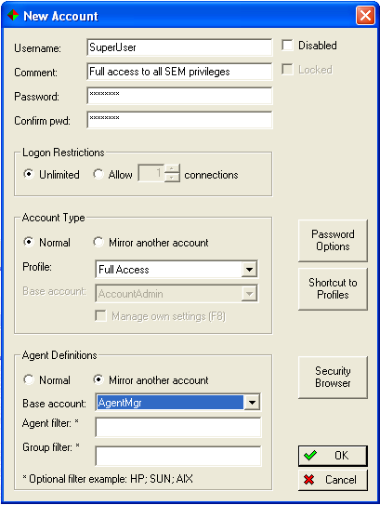

Click “OK” to close the User Accounts list.

- Log into the SEM account “SuperUser – make sure it can access the “Managers” -> “SEM Users” menu option.
Change the “F8” settings for this account (press function key <F8>) and change the “Selection Window” options for “Panes” and “Displays” as follows:
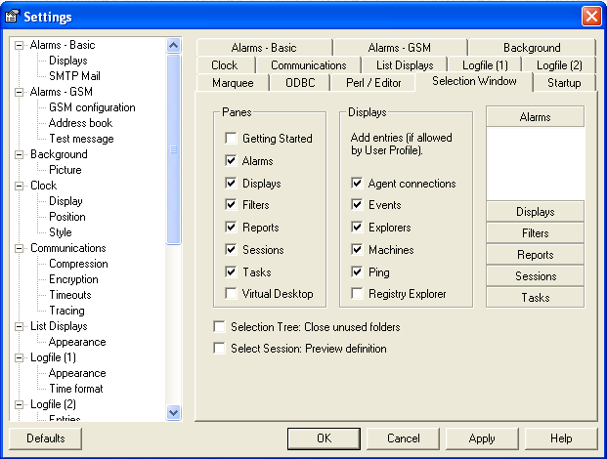
Then log out of the SuperUser account.

- Create a “Named” SEM account for yourself and “Mirror” it to the “SuperUser” Account using:
“Managers” -> “SEM Users” -> “Accounts”
Give this account a password; Mirror the Account Type to “SuperUser”; and Mirror it to the “AgentMgr” for Agent Definitions.
Switch on the checkbox: “Manage own settings (F8)”.

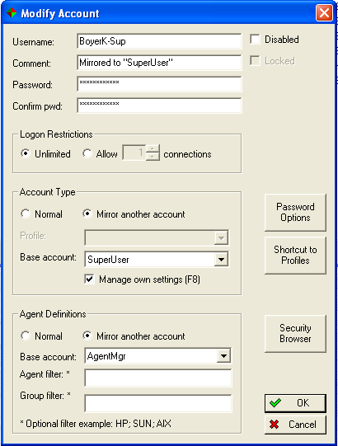

Log in to SEM as yourself and make sure you have access to the
“Managers” -> “SEM Users” -> “Accounts” menu option.
Ensure that the <F8> settings are as in the previous step.

- Log out of all SEM accounts except your own.

- Memorize or keep the “System” password somewhere secure, and do not log into that account again except under exceptional circumstances.
- Tidy-up the SEM accounts list by deleting all (boilerplate) accounts put there by the SEM installation, leaving only the following accounts defined in the list:
AgentMgr
SuperUser
System
<Your Own Account>
- After we have (next) looked at “SEM Profiles” and “SAcM Access Control Tokens” we will create all other SEM user accounts for those people who have a need to access the system.

SEM Profiles:
SEM Profiles grant permissions for SEM “Framework” features (Broad-level system-wide permissions) as compared to “SAcM Access Control Tokens”( that give detailed permissions specifically or User Account Management).

- We probably need only two different Profile settings in HealthNet, one for use by SuperUser and the other for all other SEM users.
Tidy up the SEM profiles by deleting all but the “Full Access” Profile put there by the SEM installation, using the following menu option:
“Managers” -> “SEM Users” -> “Profiles”
“System”, “AgentMgr” and “SuperUser” accounts will use the “Full Access” profile.

- Create a new Profile called: “HealthNet User Account Managers”.
Suggested Minimum settings are as follows. We may have to “Fine-tune” these later. Start by pressing the “None” button, then add back in:



We need to add an appropriate SAcM Access Control Token to this Profile, but we need to create that first, so save this Profile and we will edit it later to add in the new token.

- Familiarize with “Master Profile” – an over-riding Profile used to completely remove any unwanted features from the HealthNet installation.
“Managers” -> “SEM Users” -> “Master Profile”

SAcM Access Control Tokens:
“SAcM Access Control Tokens” define permissions for User Account Management.

- Create a new “SAcM Access Control Token” using the menu option:
“Managers” -> “SEM Users” -> “Tokens”
i.e. Copy and rename the “SAcM Permissions” token, changing the name from “Copy of SAcM Permissions” to:
“SAcM Permissions – HealthNet User Manager”
… in the “Title” field.
- Modify the “SAcM Permissions – HealthNet User Manager” token as follows:
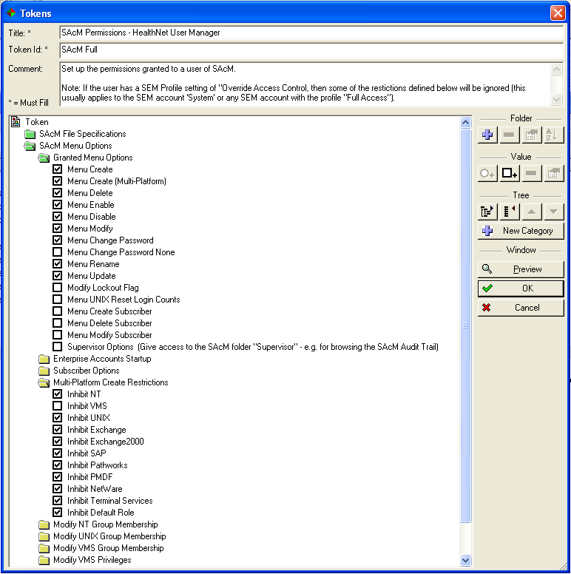

We may make further changes to this token to fine tune the permissions given to HealthNet User Account Managers.

- Create a second token by copying the “SAcM Permissions – HealthNet User Manager” token and changing the name from: “Copy of SAcM Permissions – HealthNet User Manager” to:
“SAcM Permissions – HealthNet Supervisor”
Modify the Supervisor token, and under the folders:
“SAcM Menu Options” -> “Granted Menu Options”
(see previous screenshot)
… check the “Supervisor Options” checkbox.
- Save the changes to tokens by pressing “OK” on the Account Tokens” window.
- Add the “SAcM Permissions – HealthNet User Manager” token to the Profile: “HealthNet User Account Managers”.
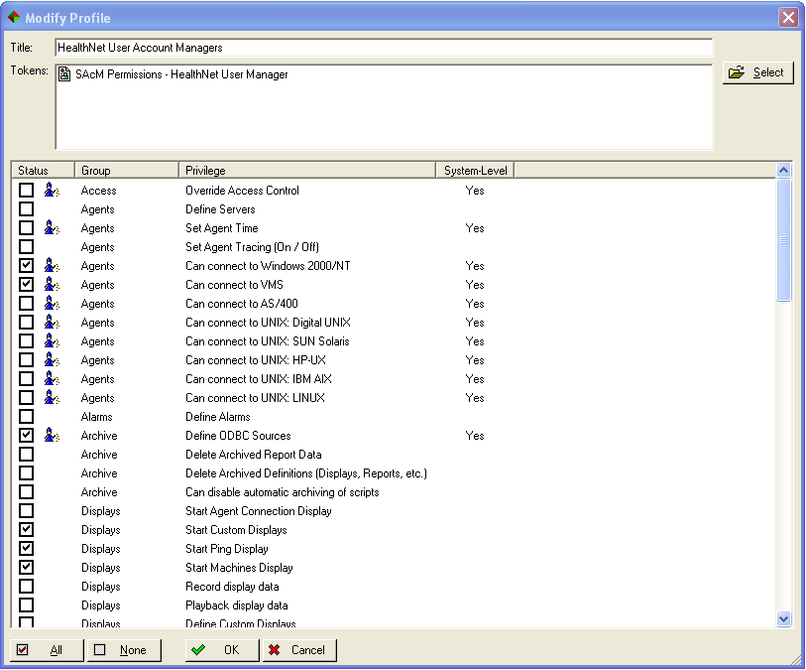
“Managers” -> “SEM Users” -> “Profiles”

- Add the “SAcM Permissions – HealthNet Supervisor” token to the Profile: “Full Access”. (& remove all other tokens on this Profile).

Map the SAcM Library to Users:
- Map the SAcM library to the generic accounts. The mapping will be inherited through the mirrors to the named accounts. We will later create a set of favorites in each generic account and then unmap the libraries so that only “Favorites” are available. This means that unwanted windows for non-relevant platforms and applications will not clutter the options available to SEM users, and importantly will not cause performance overheads.
Enterprise Accounts:
- Verify that the SAcM Enterprise Accounts Window can access and load all the accounts from all the VMS servers (SYSUAF files) {but only connect to one server in each cluster, else we will view duplicate account records}
- Modify an Account to ensure that the access has been set up correctly.

Options Cache:
- Describe / become familiar with the Central Options cache.

- Understand / become familiar with the local Options Cache
- Understand how to / the need to refresh the Options Cache from the Enterprise Accounts Window, and how to suppress the refresh if performance is an issue.

- Understand / become familiar with the refreshing the local Options Cache.

Multi-Platform Create – Templates:
- Become familiar with the “Create - (Multi-Platform )” menu option.

- Become familiar with the “Create - (Multi-Platform )” templates.

- Discuss “Create - (Multi-Platform ), Default Roles”

Favorites:
- Familiarize with Favorites
- Create some Favorites in Generic Accounts, Unmap Libraries for significant improvement in start-up performance and memory usage.
- Check out Mirrored accounts linking to Generic Favorites.
Subscriber DB:
- We can consider introducing the Subscriber DB into HealthNet at a subsequent phase. We should discuss its purpose and the possibilities for it in HealthNet.

Web Access Request (WAR) DB:
- The Web Access Request (WAR) DB is rather like an API into SAcM. I do not think that HealthNet have a need for the WAR DB at this stage, but at some time (perhaps in April) we should discuss the purpose of the WAR DB and the possibilities for it in HealthNet.

Roles Based Access Control (RBAC):
- RBAC is a product under development – due for release early 2008.

