Testing CAS-01298

14 April 2008
Initial test

Test-purpose

Verify the correct assignment of the Active Directory fields “title” (being the “Organizational Tile”) and “PersonalTitle” from the Susbcriber fields “jobtitle” and “title” (being the “Personal Title”)

Make sure, these values are correctly displayed in the main SAcM displays

Also, verify the correct updating of these fields on correspondence with their counterparts in the HR-file, during a Synchronize.

As well, verifying the correct functioning of the custom workaround (which falls back to the old situation, in where the Subscriber field “title” is being mapped to the AD field “title”)

The tests are outlined in various parts:
- Verify correct assignment of the title-fields on a [Multiplatform Create] command
- Verify correct displaying of the title-fields on a [Modify Account] command
- Verify correct displaying of the business-title field on a [Exchange2000 Create Mailbox] command
- Make a change on these both fields in the HR-file, perform a [Synchronize] and a [Process Requests] run and verify that both the subscriber-fields and AD-fields a properly updated.
- Apply the custom workaround, to return to the old situation and re-test initial test I, II, III and IV

Implementation

Update to SAcM 2.2 Release Date: 11-Apr-2008

Note: In regard to this exercise, I created a column-layout “title versus job-title” in the [Subscriber DB] display. This layout shows columns regarding the title and job-title, as being assigned to the subscribers.

Applied the following customizations:
Initial test I

[Mike Schofield – 9 Apr 2008]
The custom include file needs to be updated to make the new field read-only along with all the other fields on the AD pages of the Windows Modify form:

@{{CUSTOM_CODE_FINISH(Modify-10-Script-Fields)

print "PT ! \n";

… also I notice that the CC Manager field has not been made read-only. This might be deliberate, or it might be read/write because the field has been added to the form after the customisation was made. Please check whether they want the CC Manager field to be read only, and if so you need to add the following code also

print "MQ ! \n";

Initial test V

[Mike Schofield – 9 Apr 2008]
… also note that if Organon decide that they want the “Business Title” to be defaulted with the Personal Title from the Subscriber field (as it is now), then the following code needs to be added to the customisation script.

… between the lines:

@{{CUSTOM_CODE_FINISH(Create-Multi-Platform-15-Script-Fields)
@}}CUSTOM_CODE_FINISH(Create-Multi-Platform-15-Script-Fields)

… add:

print "XT : $Classes{\"SAcM Subscriber\"}{\"TI\"}{\"value\"}\n"; # Title

(as part of the other subscriber handling code)
[Arvid Kuipers – 14 Apr 2008]
Added the following lines to the CustomCompRules.txt file:
FLD_TITLE : CompFlag => 2 | HRField => Title | SubCode => TI | HRCode => XI | Length => $SubPeL_TITLE | AD => title
FLD_JOB_TITLE : CompFlag => 2 | HRField => JobTitle | SubCode => TJ | HRCode => YL | Length => $SubPeL_JOB_TITLE | AD =>

In the customization-scipt, between the lines:

@{{CUSTOM_CODE_FINISH(Exchange2000-Create-Mailbox-Script-Fields)
@}}CUSTOM_CODE_FINISH(Exchange2000-Create-Mailbox-Script-Fields)

Added:
print "XT : $Classes{\"SAcM Subscriber\"}{\"TI\"}{\"value\"}\n"; # Job / Business Title

Currently running versions

Machine | Application | Version / Build
OSSSYSGM01 | SAcM | SAcM 2.2 Release Date: 11-Apr-2008
OSSSYSGM01 | SEM | 2.2 build 3711
OSSSYSGM01 | Agent | 2.2 build 3695
OSSSYSGM01 | SEM Client | 2.2 build 3711
OSSDCEMEA01 | Agent | 2.1 build 3376
OSSMS01 | Agent | 2.1 build 3603
OSSFS04 | Agent | 2.1 build 3695
OSSWS01 | SEM Client | 2.1 build 3635

Test

Initial test I (succeeded):
- Opened the [Subscriber DB] display and made note of mrs. van der Ra, a product manager who hasn’t been assigned an account yet.
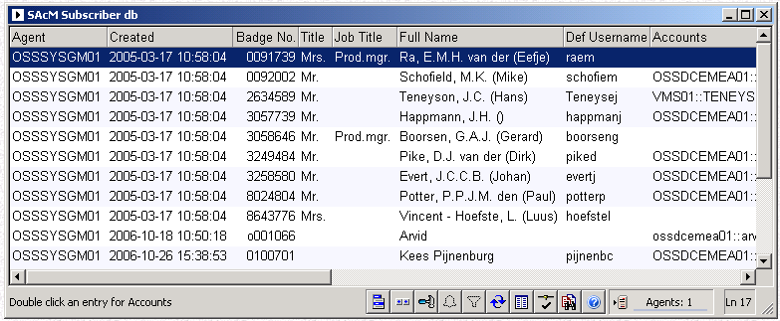
- Started the [Multiplatform Create] command on this account.
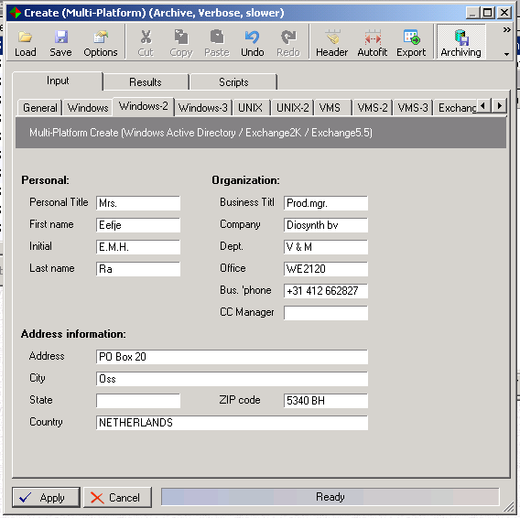
Made note of the initially correct defaulted titles on the [Windows-2] page and applied the account-creation
- The account was created successfully

Results
Started: OSSDCEMEA01 (Server)
OSSDCEMEA01: Connecting...
OSSDCEMEA01: Connected
OSSDCEMEA01: Target = Windows 2000/NT (Server)
OSSDCEMEA01: Pre-processing Input
OSSDCEMEA01: Pre-processing Output
OSSDCEMEA01: Input
OSSDCEMEA01: Script sent
OSSDCEMEA01: Output
OSSDCEMEA01: Script executed
Home directory spec = "\\OSSFS04\I$\users\R\raem\Home"
Account raem created in Active Directory.
LDAP User Login Name set to raem (raem@sup-organon.nl)
LDAP distinguished name : CN=raem,OU=Test01,DC=sup-organon,DC=nl
First name set to: Eefje
Initials set to: E.M.H.
Last name set to: Ra
Office set to: WE2120
Telephone number set to: +31 412 662827
Street address set to: PO Box 20
PO Box set to: PO Box 20
Zip/Postal set to: 5340 BH
Country set to: NETHERLANDS
City set to: Oss
Business Title set to: Prod.mgr.
Personal Title set to: Mrs.
Company set to: Diosynth bv
Department set to: V & M
FAX set to: +31 412 662156
Comment set to: 0091739#Live#
Full Name set to: Ra, E.M.H. van der (Eefje)
Home Directory set to: \\OSSFS04\raem$
Home Dir Drive set to: X:
Password set to: Biljart1
Full Name set to: Ra, E.M.H. van der (Eefje)
User Account Flags set to: 512
Active Directory updated.
Account raem no local groups selected.
OSSDCEMEA01: Post-processing Input
OSSDCEMEA01: Post-processing Output
Audit Sequence Number = 50/3725/administrator
Integration Classes - Apply Action - Script
Integration Classes - Apply Action - Output
Account registered in Subscriber database.
Started: OSSFS04 (Server)
OSSFS04: Connecting...
OSSFS04: Connected
OSSFS04: Target = Windows 2000/NT (Server)
OSSFS04: Pre-processing Input
OSSFS04: Pre-processing Output
OSSFS04: Input
OSSFS04: Script sent
OSSFS04: Output
OSSFS04: Script executed
Home directory spec = "\\OSSFS04\I$\users\R\raem\Home"
OSSFS04: Post-processing Input
OSSFS04: Post-processing Output
Archived: OSSDCEMEA01,OSSFS04: Results
Finished

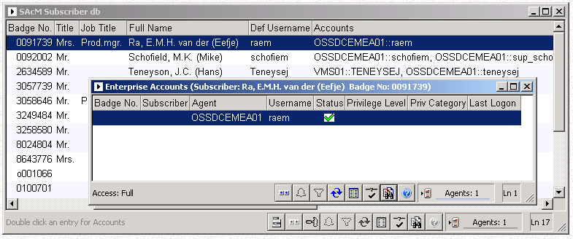

- Jumped to ADSIEDIT.MSC to verify the assignment of the correct AD-fields
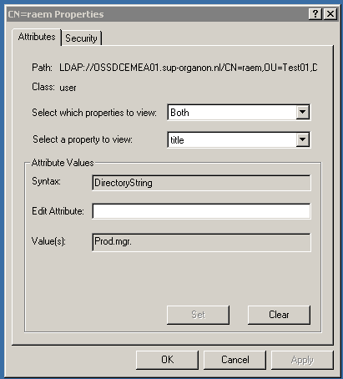
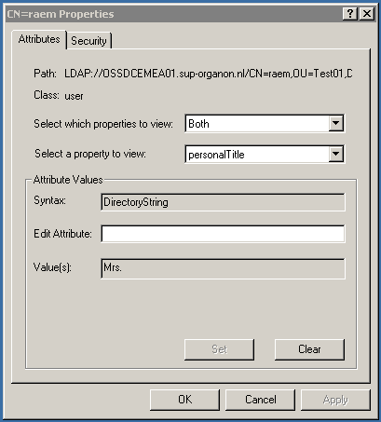

Initial test II (succeeded):
- In continuation on test I, opened this account for modification.
In the [Modify Account] display:
  - The personal title is correctly displayed on the [AD-1] page
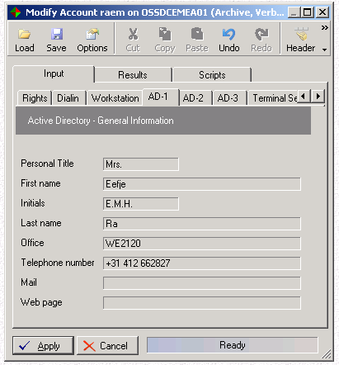
  - The business title is correctly displayed on the [AD-3] page
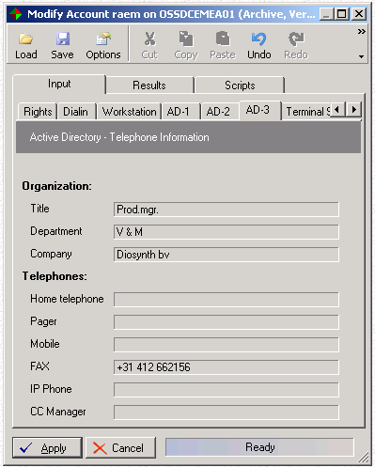
- Aborted the [Modify] command

Initial test III (succeeded):
- In continuation on test II, started the [Excange2000/7 Create Mailbox] command on Mrs van der Ra.
- The [Business title] field was correctly defaulted in the [Exchange2000/7 Create Mailbox] display
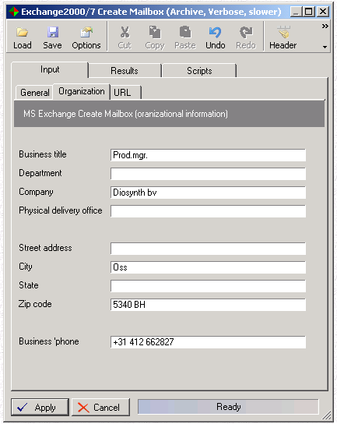

- Aborted the [Exchange 2000/7 Create Mailbox] command

Initial test IV (succeeded):
- Still in the context of Mrs van der Ra, changed her titles in the HR-file to “Ms” and “Prod.dir”
CHANGE_THRESHOLD_LIMIT=500
BadgeNo#SubsType#FullName#LastName#Partner#SubsStatus#DefUsername#DefUserRole#DistingName#OrgName#OrgUnit1#OrgUnit2#OrgUnit3#OrgUnit4#DeptName#LeaveDate#Room#Title#AccTitle#JobTitle#GeogLocality#Language#POBox#PostStreet#PostCode#PostCity#PostState#PostCountry#CountryCode#TelNo#Mobile#FaxNo#ISDN#E_Mail#CostCenter#UserGroup#VMS_UIC_Gp#VMS_UIC_Mem#UNIX_UID_Gp#UNIX_UID_Mem#CC_Mgr#SecrName#SecrTel#UDF1#UDF2#UDF3#UDF4#Comment#Location#Building#Floor#
…
0091739#Person#Ra, E.M.H. van der (Eefje)#van der Ra##Live#raem###Diosynth bv#####V & M##WE2120#Ms.##Prod.dir.#Molenweg 50#ENGLISH#PO Box 20##5340 BH#Oss##NETHERLANDS#NL#+31 412 662827##+31 412 662156###DDP#DDDP########V#####Moleneind#WE#02#
…

- Started up a Synchronize-run.
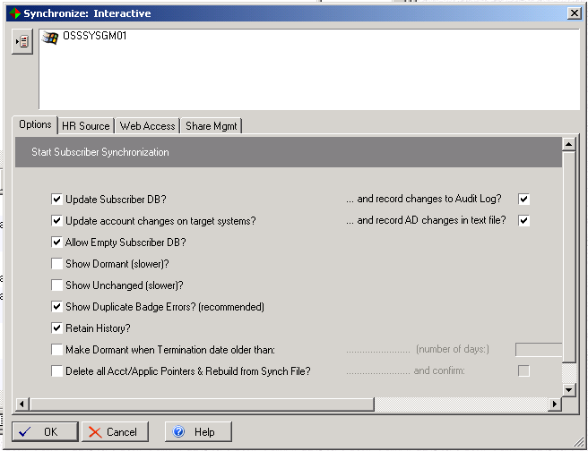
- The Synchronize spotted changes for Mrs van der Ra, in the fields [title] and [job-title]:
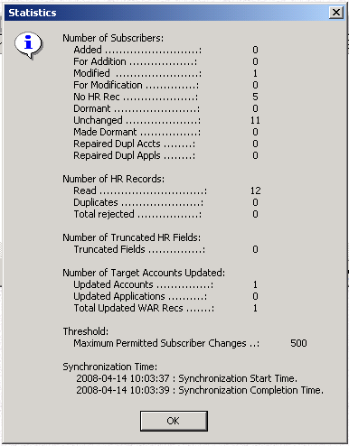

Synchronize: Interactive (Changes Only)
Agent ...............: OSSSYSGM01
Action ..............: Modified
Status ..............: #BMP(749)
BadgeNo .............: 0091739
HR: FullName ........: Ra, E.M.H. van der (Eefje)
Sub: FullName .......: Ra, E.M.H. van der (Eefje)
HR: Title ...........: Ms.
Sub: Title ..........: Mrs.
HR: Ac. Title .......:
Sub: Ac. Title ......:
HR: JobTitle ........: Prod.dir.
Sub: Job Title ......: Prod.mgr.
HR: DefUsername .....: raem
Sub: DefUsername ....: raem
HR: LastName ........: van der Ra
Sub: LastName .......: van der Ra
HR: Rec Type ........: Person
Sub: Rec Type .......: Person
HR: Rec Status ......: Live
Sub: Rec Status .....: Live

- Checked the content of the corresponding subscriber. The change on titles was implemented correctly
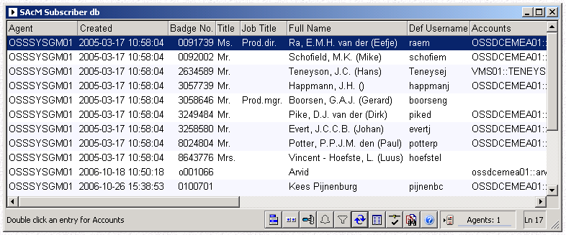

SAcM Subscriber db
Agent .................: OSSSYSGM01
Created ...............: 2005-03-17 10:58:04
Badge No. .............: 0091739
Title .................: Ms.
Job Title .............: Prod.dir.
Full Name .............: Ra, E.M.H. van der (Eefje)
Def Username ..........: raem
Accounts ..............: OSSDCEMEA01::raem
LastName ..............: van der Ra
- As well, the following WAR-record showed up in the [Process Requests] display
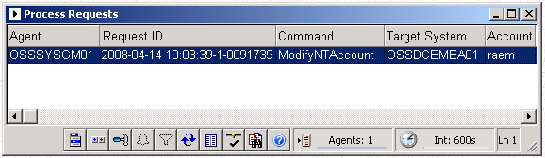
The fields [title] and [personalTitle] were included in the parameters

Process Requests
Agent ..........: OSSSYSGM01
Request ID .....: 2008-04-14 10:03:39-1-0091739
Command ........: ModifyNTAccount
Target System ..: OSSDCEMEA01
Account ........: raem
Date ...........: 2008-04-14 10:03:39
Status .........: Submitted
Param01 ........: TargetSystem
Value01 ........: OSSDCEMEA01
Param02 ........: Username
Value02 ........: raem
…
Param19 ........: title
Value19 ........: Prod.dir.
- Executed this WAR-command
The log showed the following related entries
1758: Value 87 : []
1759: Field 88 : [ResultFieldName]
1760: Value 88 : [Information]
1761: Field 89 : [ResultValue]
1762: Value 89 : [ Business Title set to: Prod.dir..]
1763: Written Results: Status = [1] Error = [OK]
1764: Field 0 : [RequestID]
1765: Value 0 : [2008-04-14 10:03:39-1-0091739]
1766: Field 1 : [ResultAgent]
1767: Value 1 : [OSSDCEMEA01]
1768: Field 2 : [ResultContext]

1949: Value 92 : []
1950: Field 93 : [ResultFieldName]
1951: Value 93 : [Information]
1952: Field 94 : [ResultValue]
1953: Value 94 : [ Personal Title set to: Ms..]
1954: Written Results: Status = [1] Error = [OK]
1955: Field 0 : [RequestID]
1956: Value 0 : [2008-04-14 10:03:39-1-0091739]
1957: Field 1 : [ResultAgent]
1958: Value 1 : [OSSDCEMEA01]
1959: Field 2 : [ResultContext]
- Jumped to ADSIEDIT.MSC to verify the assignment of the correct AD-fields
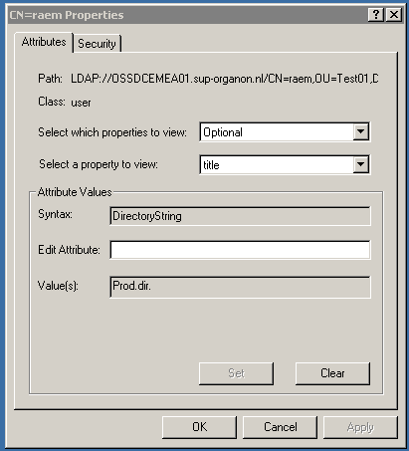
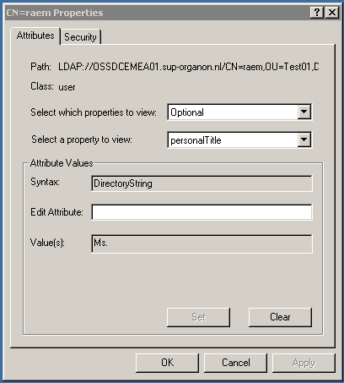
- Opening the Account for modify, gives a second confirmation that the changes have not been applied:
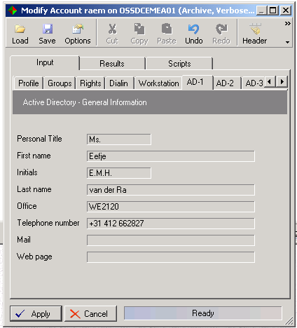
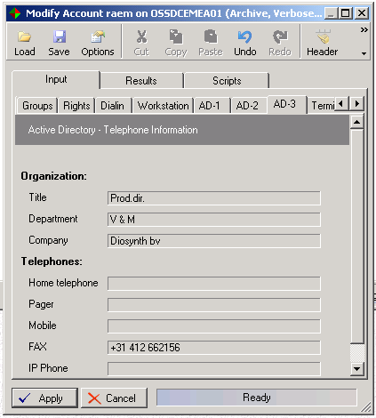

Initial test V-I (succeeded):
- Opened the [Subscriber DB] display and made note of mrs. Adam, who hasn’t been assigned an account yet.
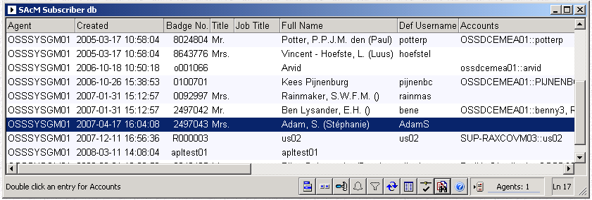
- Started the [Multiplatform Create] command on this account.
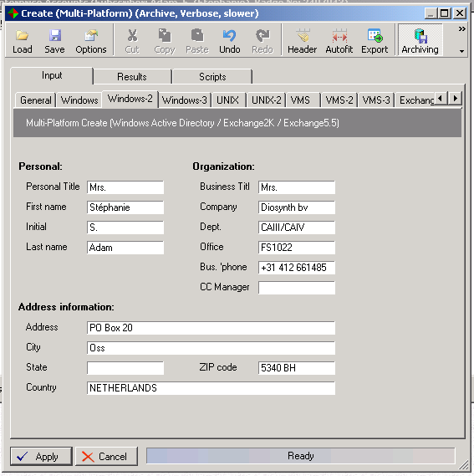
Made note of the initially correct defaulted titles on the [Windows-2] page and applied the account-creation
- The account was created successfully

Results
Started: OSSDCEMEA01 (Server)
OSSDCEMEA01: Connecting...
OSSDCEMEA01: Connected
OSSDCEMEA01: Target = Windows 2000/NT (Server)
OSSDCEMEA01: Pre-processing Input
OSSDCEMEA01: Pre-processing Output
OSSDCEMEA01: Input
OSSDCEMEA01: Script sent
OSSDCEMEA01: Output
OSSDCEMEA01: Script executed
Home directory spec = "\\OSSFS04\E$\users\A\adams\Home"
Account adams created in Active Directory.
LDAP User Login Name set to adams (adams@sup-organon.nl)
LDAP distinguished name : CN=adams,OU=Test01,DC=sup-organon,DC=nl
First name set to: Stéphanie
Initials set to: S.
Last name set to: Adam
Office set to: FS1022
Telephone number set to: +31 412 661485
Street address set to: PO Box 20
PO Box set to: PO Box 20
Zip/Postal set to: 5340 BH
Country set to: NETHERLANDS
City set to: Oss
Business Title set to: Mrs.
Personal Title set to: Mrs.
Company set to: Diosynth bv
Department set to: CAIII/CAIV
FAX set to: +31 412 662156
Comment set to: 2497043#Live#
Full Name set to: Adam, S. (Stéphanie)
Home Directory set to: \\OSSFS04\adams$
Home Dir Drive set to: X:
Password set to: Biljart1
Full Name set to: Adam, S. (Stéphanie)
User Account Flags set to: 512
Active Directory updated.
Account adams no local groups selected.
OSSDCEMEA01: Post-processing Input
OSSDCEMEA01: Post-processing Output
Audit Sequence Number = 51/3729/administrator
Integration Classes - Apply Action - Script
Integration Classes - Apply Action - Output
Account registered in Subscriber database.
Started: OSSFS04 (Server)
OSSFS04: Connecting...
OSSFS04: Connected
OSSFS04: Target = Windows 2000/NT (Server)
OSSFS04: Pre-processing Input
OSSFS04: Pre-processing Output
OSSFS04: Input
OSSFS04: Script sent
OSSFS04: Output
OSSFS04: Script executed
Home directory spec = "\\OSSFS04\E$\users\A\adams\Home"
OSSFS04: Post-processing Input
OSSFS04: Post-processing Output
Started: OSSMS01 (Server)
OSSMS01: Connecting...
OSSMS01: Connected
OSSMS01: Target = Windows 2000/NT (Server)
OSSMS01: Pre-processing Input
OSSMS01: Pre-processing Output
OSSMS01: Input
OSSMS01: Script sent
OSSMS01: Output
OSSMS01: Script executed
Home directory spec = "\\OSSFS04\E$\users\A\adams\Home"
OSSMS01: Post-processing Input
OSSMS01: Post-processing Output
Archived: OSSDCEMEA01,OSSFS04,OSSMS01: Results
Finished

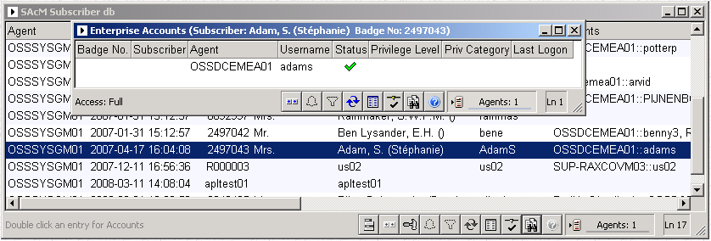

- Jumped to ADSIEDIT.MSC to verify the assignment of the correct AD-fields
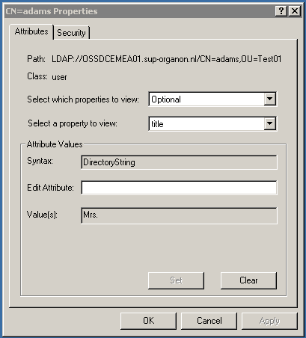
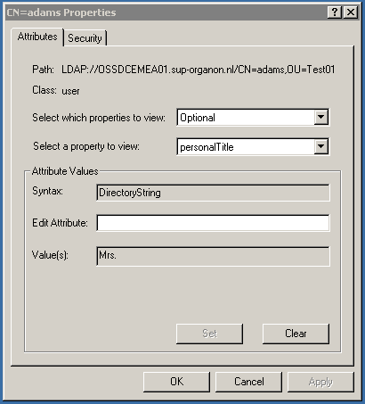

Initial test V-II (succeeded):
- In continuation on test I, opened this account for modification.
In the [Modify Account] display:
  - The personal title is correctly displayed on the [AD-1] page
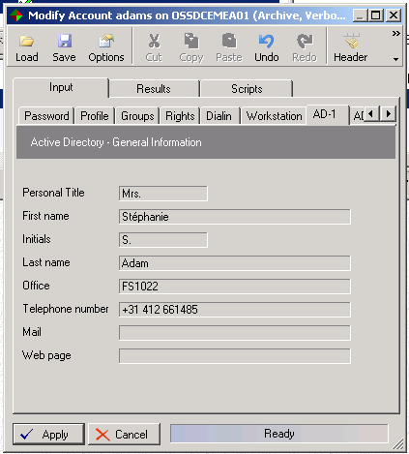
  - The business title is correctly displayed on the [AD-3] page
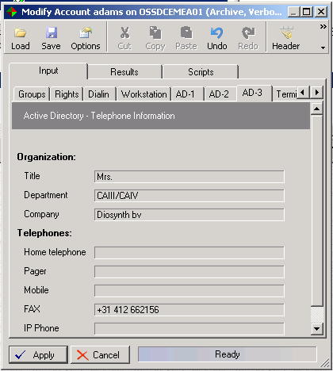
- Aborted the [Modify] command

Initial test V-III (succeeded):
- In continuation on test II, started the [Excange2000/7 Create Mailbox] command on Mrs Adam.
- The [Business title] field was correctly defaulted in the [Exchange2000/7 Create Mailbox] display
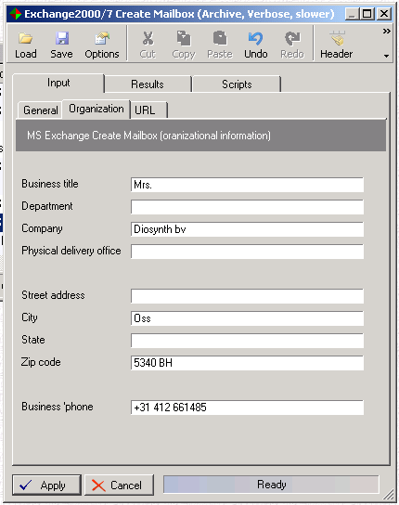

- Aborted the [Exchange 2000/7 Create Mailbox] command

Initial test V-IV (succeeded):
- Still in the context of mrs Adam, changed her title in the HR-file to “Ms”.
CHANGE_THRESHOLD_LIMIT=500
BadgeNo#SubsType#FullName#LastName#Partner#SubsStatus#DefUsername#DefUserRole#DistingName#OrgName#OrgUnit1#OrgUnit2#OrgUnit3#OrgUnit4#DeptName#LeaveDate#Room#Title#AccTitle#JobTitle#GeogLocality#Language#POBox#PostStreet#PostCode#PostCity#PostState#PostCountry#CountryCode#TelNo#Mobile#FaxNo#ISDN#E_Mail#CostCenter#UserGroup#VMS_UIC_Gp#VMS_UIC_Mem#UNIX_UID_Gp#UNIX_UID_Mem#CC_Mgr#SecrName#SecrTel#UDF1#UDF2#UDF3#UDF4#Comment#Location#Building#Floor#
…
2497043#Person#Adam, S. (Stéphanie)#Adam##Live#AdamS###Diosynth bv#####V & M##WE2120#Ms.###Molenweg 50#ENGLISH#PO Box 20##5340 BH#Oss##NETHERLANDS#NL#+31 412 661485##+31 412 662156###DDP#DDDP########V#####Moleneind#WE#02#
…

- Started up a Synchronize-run.
- The Synchronize spotted changes for mrs Adam, in the field [title]:
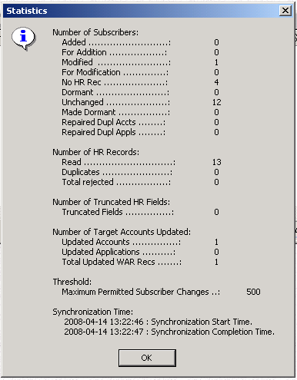

Synchronize: Interactive (Changes Only)
Agent ...............: OSSSYSGM01
Action ..............: Modified
Status ..............: #BMP(749)
BadgeNo .............: 2497043
HR: FullName ........: Adam, S. (Stéphanie)
Sub: FullName .......: Adam, S. (Stéphanie)
HR: Title ...........: Ms.
Sub: Title ..........: Mrs.
HR: Ac. Title .......:
Sub: Ac. Title ......:
HR: JobTitle ........:
Sub: Job Title ......:
HR: DefUsername .....: AdamS
Sub: DefUsername ....: AdamS
HR: LastName ........: Adam
Sub: LastName .......: Stephanie Adam
HR: Rec Type ........: Person
Sub: Rec Type .......: Person
HR: Rec Status ......: Live
Sub: Rec Status .....: Live

- Checked the content of the corresponding subscriber. The change on her title was implemented correctly
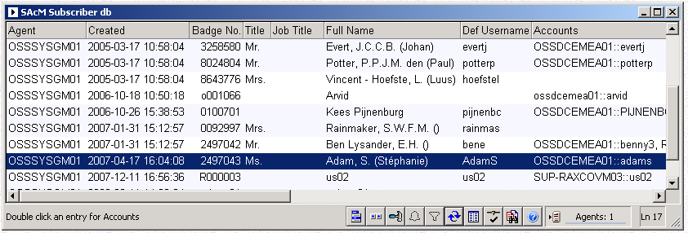

SAcM Subscriber db
Agent .................: OSSSYSGM01
Created ...............: 2007-04-17 16:04:08
Badge No. .............: 2497043
Title .................: Ms.
Job Title .............:
Full Name .............: Adam, S. (Stéphanie)
Def Username ..........: AdamS
Accounts ..............: OSSDCEMEA01::adams
Rec Type ..............: Person
Status ................: #BMP(747)
Record Status .........: Live
LastName ..............: Adam

- As well, the following WAR-record showed up in the [Process Requests] display
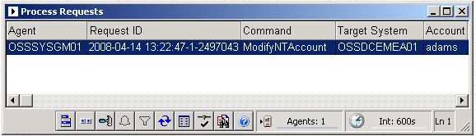
The fields [title] and [personalTitle] were included in the parameters

Process Requests
Agent ..........: OSSSYSGM01
Request ID .....: 2008-04-14 13:22:47-1-2497043
Command ........: ModifyNTAccount
Target System ..: OSSDCEMEA01
Account ........: adams
Date ...........: 2008-04-14 13:22:47
Status .........: Submitted
…
Param02 ........: title
Value02 ........:
Param03 ........: DisplayName
Value03 ........: Adam, S. (Stéphanie)
Param04 ........: GivenName
Value04 ........: Stéphanie
…
Param06 ........: sn
Value06 ........: Adam
Param07 ........: title
Value07 ........: Ms.
…
Param12 ........: TargetSystem
Value12 ........: OSSDCEMEA01
Param13 ........: Username
Value13 ........: adams
…
Param16 ........: sn
Value16 ........: Adam

- Executed this WAR-command
The log showed the following related entry
1577: Value 82 : []
1578: Field 83 : [ResultFieldName]
1579: Value 83 : [Information]
1580: Field 84 : [ResultValue]
1581: Value 84 : [ Business Title set to: Ms..]
1582: Written Results: Status = [1] Error = [OK]
1583: Field 0 : [RequestID]
1584: Value 0 : [2008-04-14 13:22:47-1-2497043]
1585: Field 1 : [ResultAgent]
1586: Value 1 : [OSSDCEMEA01]
1587: Field 2 : [ResultContext]
1588: Value 2 : []

- Jumped to ADSIEDIT.MSC to verify the assignment of the correct AD-fields
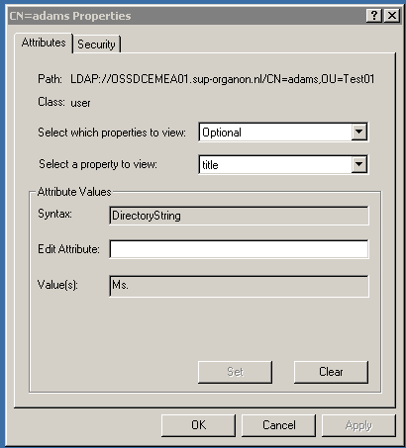
Note the [personalTitle] field still being set to the old value
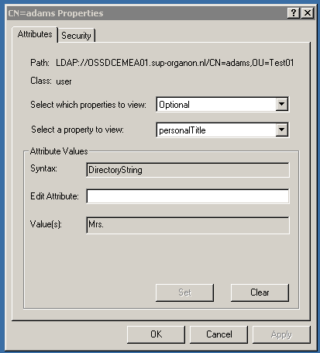

Additional code-changes to be made:

- None

