Draft Text for Web Page and as an intro to User Guide…

_____________________________________________

Sysgem File Synchronizer (SFiS)

– the optimum solution for Remote Server Configuration Management

The Challenge

Q: How do you edit configuration files on multiple remote servers, on the various UNIX and Linux platforms, especially when there are large numbers of servers to manage?

Q: How do you control server-specific differences in configuration files on separate systems?

Q: Having once set up the configuration on multiple systems, how do you monitor them for being modified to stray away from corporate policies?

Q: How do you make a planned update to configuration files when there are many servers to control?

Q: As a security manager, how do you ensure that SSH configuration settings are not compromising security and that they are not being changed by unauthorized individuals?

Q: How do you audit track configuration changes and attribute modifications to individuals?

Q: Above all, how do you do all this in a simple, economical, effective and reliable fashion?

A: The answers to all these questions can be found below…

The Solution

With Sysgem File Synchronizer (SFiS) you can manage your configuration files on multiple target servers from definitions held in a central file repository.

SFiS provides a complete and secure environment to build a central store of ‘source’ configuration definition files. They define how target configuration files should look including all the variations required for each separate server.

And the best thing is: using SFiS could not be simpler!

Use Sysgem File Synchronizer to:

- Monitor files on remote servers from a central point.
- Raise automatic alarms when unexpected changes occur.
- Distribute and deploy configuration file updates.

Control access to this powerful yet ‘simple to use’ tool and delegate options to a very fine level of granularity with precision and confidence. All options used are fully audited and may subsequently be browsed and analysed.

… and why stop at configuration files? Indeed any file required on multiple servers can be handled by Sysgem File Synchronizer (SFiS).

Central Source File Manager

The SFiS GUI lists source files permitted for each user to edit, to create new files, to delete old ones, etc. Source files contain details of the text to be stored on target servers and also have meta-language rules to define variants for different servers.

The meta-language comprises an extremely simple set of clauses. A clause is a single character placed in the first character position in each line of a source file. A clause defines whether the rest of the line is:

- text for the target file;
- a specification of the name and location of the target file;
- for which server the particular text applies;
- etc.

All changes to source files are audit logged giving details of who made the change, which files were changed, etc.

Source files are held in a single Sysgem folder stored with restricted access. The files incorporate a check-sum and are encrypted for maximum integrity and security.

Distribution and Deployment of Configuration Files

Lists of servers and configuration files show whether updates are required to individual files / servers. Drilling down into individual files show the details of discrepancies between the central source definition and the target file. Those files needing an update are selected and, with a single key click, synchronized with the central definition.

Automatic Monitoring of Target Configurations

It is very easy to set up ‘Unattended Mode Operations’ to periodically and continually monitor the state of target files by comparing them to their central source definition. The frequency of refreshing a report can be as short or as long as you wish.

When your criteria for taking action are met, an alarm is automatically triggered and the action taken, such as to notify by email the details of the inconsistency.

Interactively browse the network at any time and take a report of the current situation. Save this information as an HTML report or as a spreadsheet/text file/MS Word document/etc.

Configuration Management

Shell commands are run, as a pre- or post- file-update task, to take configuration action on the impending or completed file-update. Customer and server specific shell commands are embedded in the source file and are automatically invoked as part of the file synchronization task.

Typical files controlled by Sysgem File Synchronizer are:

- /etc/sudoers
- /etc/hosts
- /etc/crontab
- /etc/sysctl.conf
- /etc/group
- /etc/shells
- /etc/services

Access Control & Audit Trail Logging

Access to the File Synchronizer and all the individual features within it can be controlled per user. Different levels of privileges can be given to different users. For example, control access to:
- Named servers
- Nominated files (both target and source files)
- Script commands
- Menu options
- etc.

All actions taken by individual users to source files or target systems are recorded in a central Audit Trail database. An Audit Browser window is provided with the product allowing all past events taken by the product to be reviewed, analysed and included in reports.

Predictability:

Reports on source files give information on the applicability of data and shell commands per server as shown in the screen shot below:

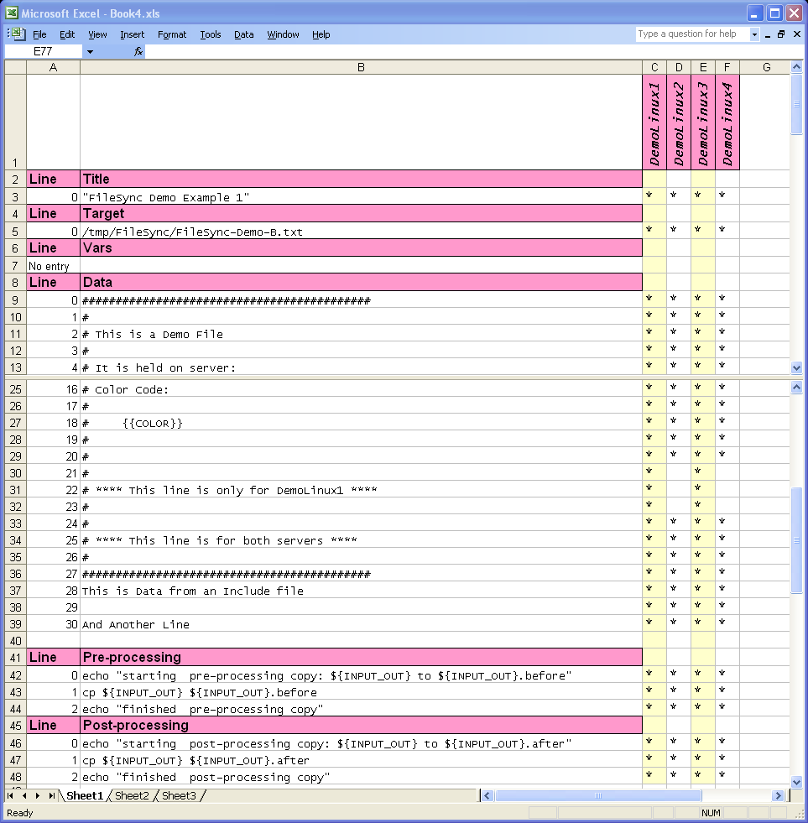
View which data & shell commands apply to individual servers and not to others

For More Information:
Please contact Sysgem by email on office@sysgem.com for further information.

Key Benefits

- Ease of Configuration Management:
  - Control Configuration files from one central point
  - Convenient and easy distribution of updates
  - Check status and look for exceptions for the entire network in a single display window

- Increased Integrity & Increased Security :
  - Automatic monitoring resulting in alarms when corporate policies not being adhered to
  - Audit trail
- Reduced Effort:
  - Delegate with fine granularity of privileges
  - Ease of Creating of Reports

Well, the alternative to Sysgem’s File Synchronizer is to log into each of the multiple target systems, check the content of the files and update them manually – a never-ending job for a system manager or security manager. Without SFiS, as soon as the last server has been checked it would be time to start with the first one again! When large numbers of servers are involved, this would be a bit like the never-ending job of…

“Painting the Forth Rail Bridge!”

Supported Environments

Platforms
‘Agents’ for the current version of SFiS is supported on most UNIX variants:

- Sun Solaris
- IBM AIX
- HP UX & Tru64
- SGI Irix
- Linux on x86
- Linux on IBM System z
- Linux on Itanium

Coming soon - check for availability:

- MS Windows 7/Vista/XP/2008/2003/2000/NT
- OpenVMS (Itanium (IA64) / Alpha / VAX)

The GUI and the Central File Repository are supported on:

- MS Windows 7/Vista/XP/2008/2003/2000/NT

Web Page mock up….

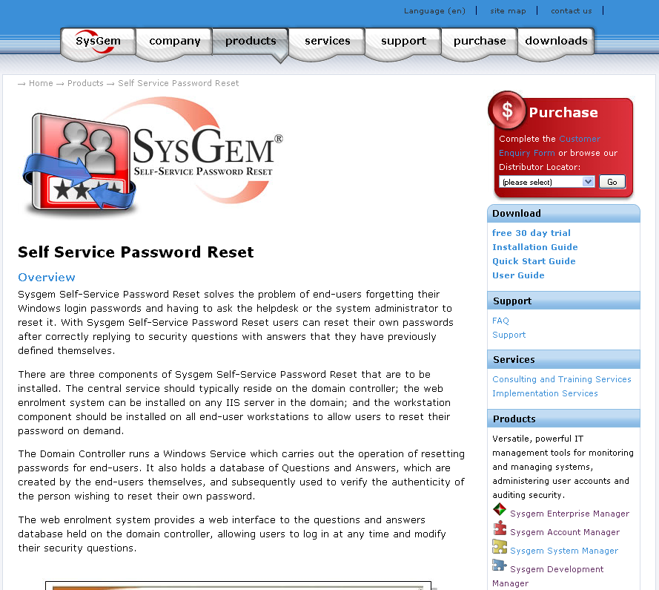
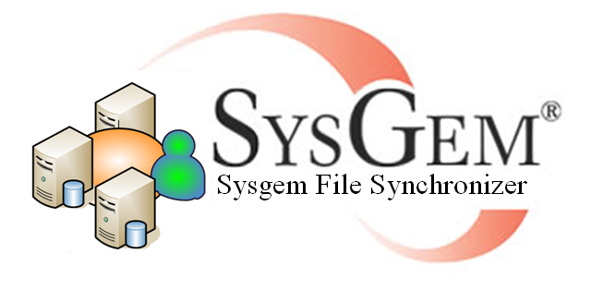
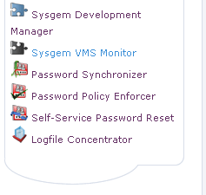
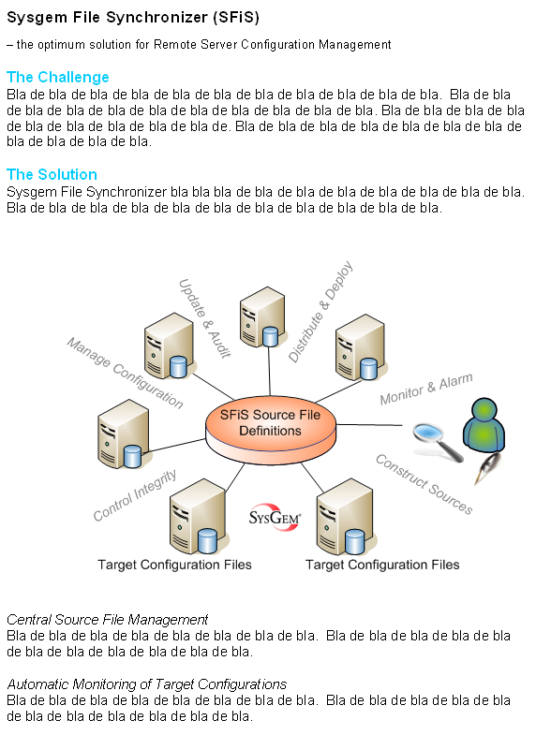

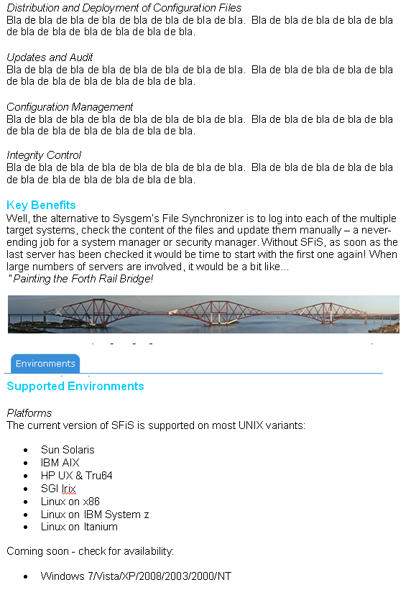
File Sync “Place-holder” Logo

